Supplementary information
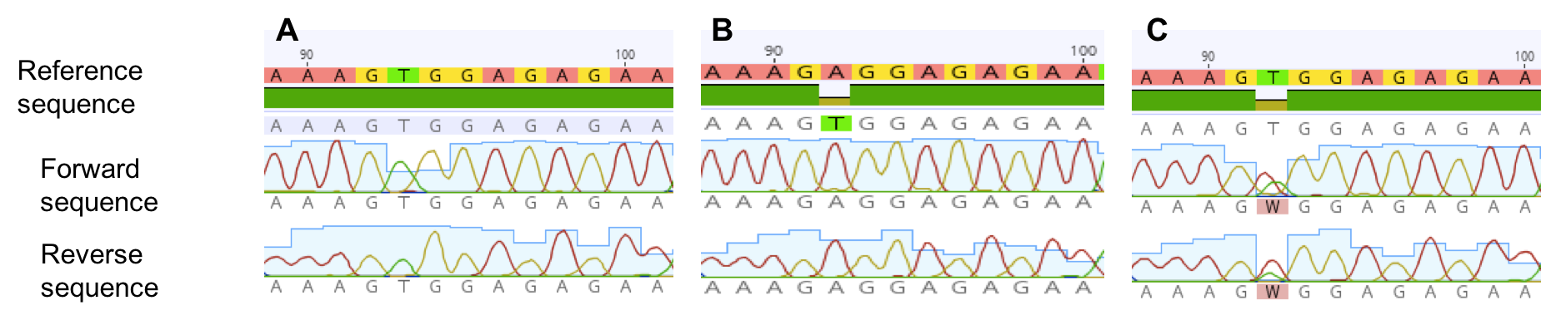
Supplementary Figure 1: Electropherograms showing sequence data from individuals (A) Homozygous for the NPHS2 V260 allele (T/T) (B) Homozygous for the NPHS2 260E allele (A/A) (C) Heterozygous for the NPHS2 V260E allele (A/T), from the sequencing in the forward and reverse directions.

Supplementary Table 1: APOL1 genotype distribution among FSGS cases and controls

Genotype  Frequency | Allele Frequency | FSGS (30) | SSNS (10) | SRNS (20)* | Controls (n=176)
0 risk allele  G0/G0 |  | 14 (46%) | 3 (30%) | 11 (55%) | 117 (66.5%)
1 risk allele  G0/G1  G0/G2  Total |  | 5 (17%)  8 (27%  13 (44%) | 3 (30%)  4 (40%)  7 (70%) | 2 (10%)  4 (20%)  6 (30%) | 20 (11.4%)  27 (15.3%)  47 (26.7%)
2 risk alleles  G1/G1  G1/G2  G2/G2  Total |  | 0  1 (3%)  2 (7%)  3 (10%) | 0  0  0  0 | 0  1 (5%)  2 (10%)  3 (15%) | 2 (1.1%)  3 (1.7%)  7 (4%)  12 (6.8%)
 | G0 allele  G1 allele  G2 allele | 0.683  0.100  0.216 | 0.650  0.150  0.200 | 0.700  0.075  0.225 | 0.798  0.077  0.125
* Of the 20 SRNS 20 cases only 5 cases did not have the V260E variant (3 of these individuals had the G0/G0 genotype, 1 individual had G0/G2 genotype and 1 individual had G2/G2 genotype)

