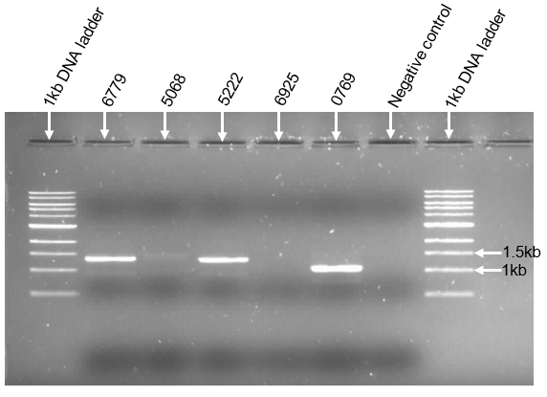
Supplementary figure 2: Agarose gel electrophoretogram showing the separate PR-RT and IN nested PCR results. Samples in which PR-RT was not detected with the multiplex PCR, separate PR-RT nested PCR reactions were prepared using amplicon from the first round of the multiplex PCR. PR-RT was detected in two samples (6779 and 5222), however PR-RT was not detected in two samples (5068 and 6925) possibly due to primer mismatch. A separate IN nested PCR was prepared for sample 0769 as it had a faint band with the multiplex PCR. kb – kilobase; DNA – deoxyribonucleic acid.

