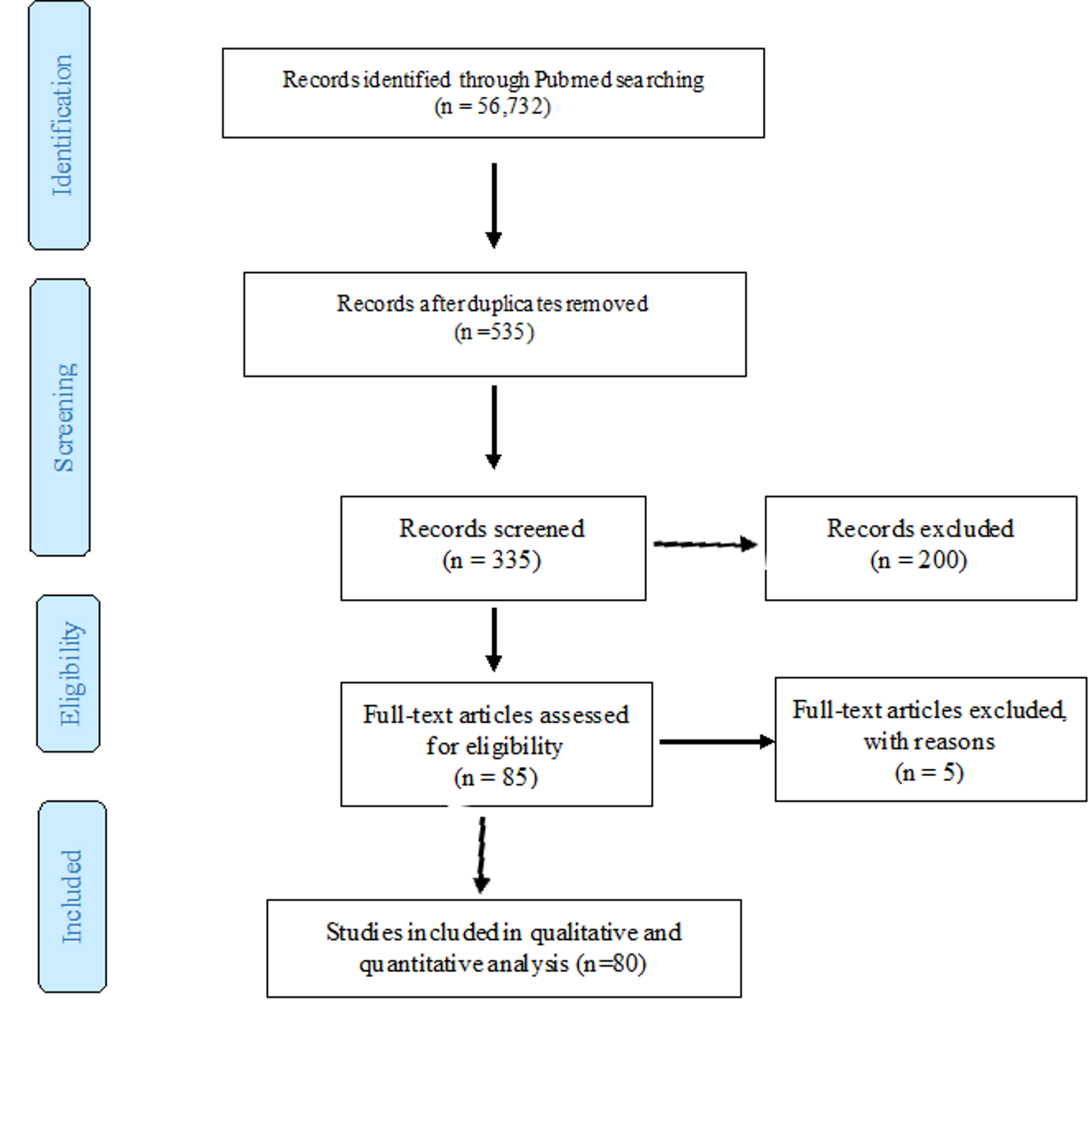
Figure S1. A PRISMA diagram showing the literature search strategy, inclusion and exclusion criteria, and the final number of included articles.

