Electrocapacitive removal of Na and Cd ions from contaminated aqueous solution using Fe₃O₄@PEDOT:PSS modified chitosan nanosheets
Saliu OD^{a,b*}, Leping Oª, Tunde L. Yusufª, Adeniyi A.G^{c} and Ramontja J^{a*}
ªEnergy, Sensors and Multifunctional Nanomaterials Research Group, Department of Chemical Sciences, University of Johannesburg, PO Box 17011, Doornfontein 2028 Johannesburg, South Africa
^{b}Department of Industrial Chemistry, University of Ilorin, Ilorin, Nigeria.
^{c}Chemical Engineering Department, Faculty of Engineering and Technology, University of Ilorin, Ilorin P.M.B. 1515, Nigeria
Corresponding authors: oluwaseyis@uj.ac.za, jamesr@uj.ac.za
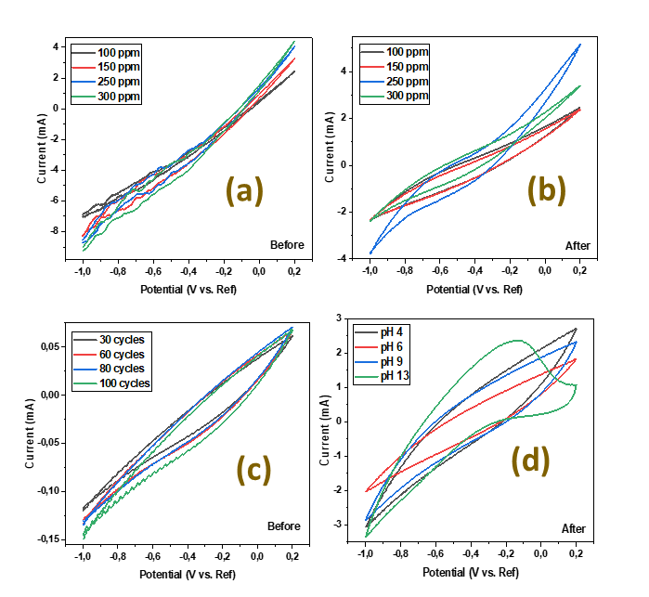
Figure S1: (a,b) CV of Na⁺ before and after CDI using nanocomposite, (c,d) CV of Na⁺ before and after CDI using nanocomposite for the effect of pH

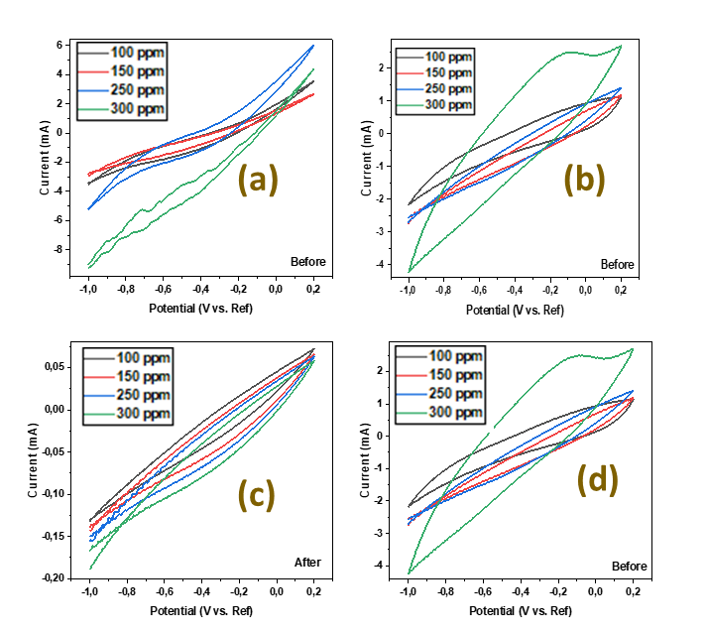
Figure S2: (a,b) CV of Na⁺ before and after CDI using nanocomposite, (c,d) CV of Na⁺ before and after CDI using nanocomposite for the effect of concentration

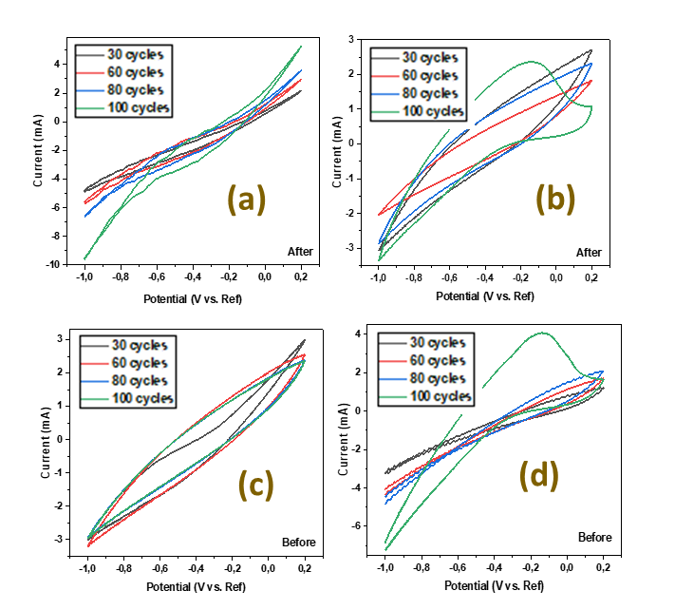
Figure S3: (a,b) CV of Na⁺ before and after CDI using nanocomposite, (c,d) CV of Na⁺ before and after CDI using nanocomposite for the effect of cycles
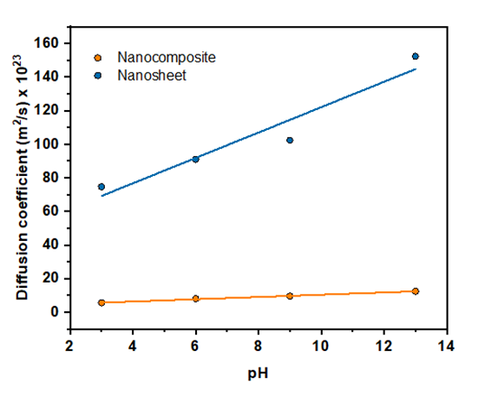
Figure S4: (a,b) Diffusion coefficient of Na⁺ before and after CDI using nanocomposite, (c,d) Diffusion coefficient of Na⁺ before and after CDI using nanocomposite for the effect of cycles

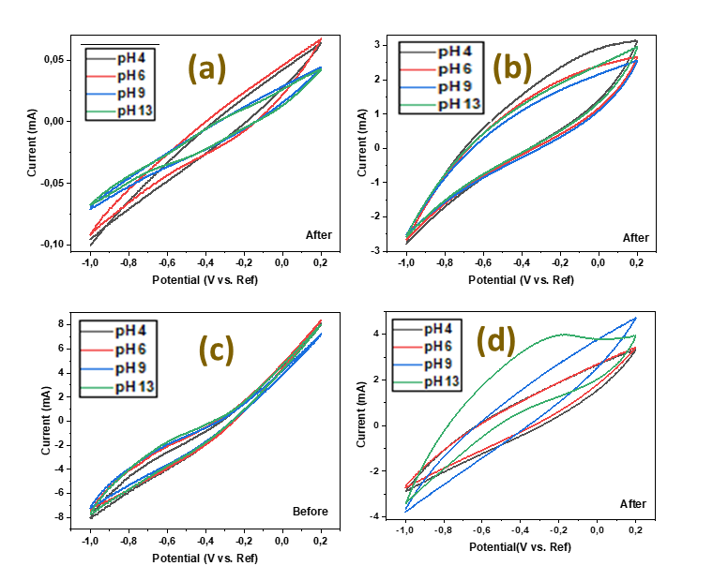
Figure S5: (a,b) CV of Cd²⁺ before and after CDI using nanocomposite, (c,d) CV of Cd²⁺ before and after CDI using nanocomposite for the effect of pH
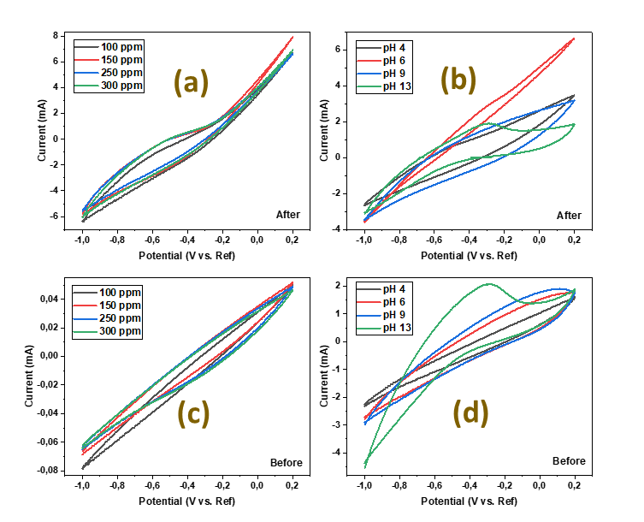
Figure S6: (a,b) CV of Cd²⁺ before and after CDI using nanocomposite, (c,d) CV of Cd²⁺ before and after CDI using nanocomposite for the effect of conc
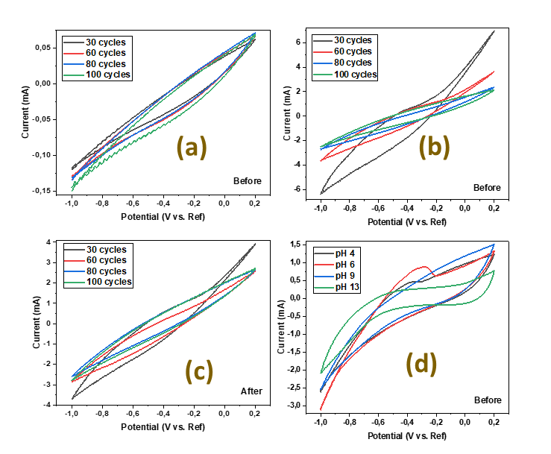
Figure S7: (a,b) CV of Cd²⁺ before and after CDI using nanocomposite, (c,d) CV of Cd²⁺ before and after CDI using nanocomposite for the effect of cycles
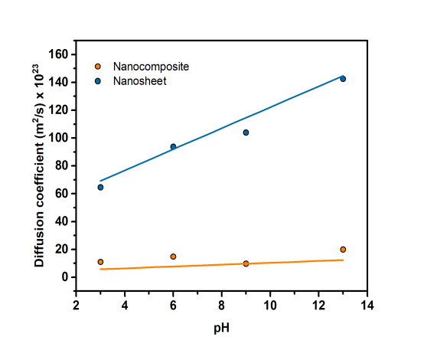
Figure S8: (a,b) Diffusion coefficient of Cd²⁺ before and after CDI using nanocomposite, (c,d) Diffusion coefficient of Cd²⁺ before and after CDI using nanocomposite for the effect of pH

