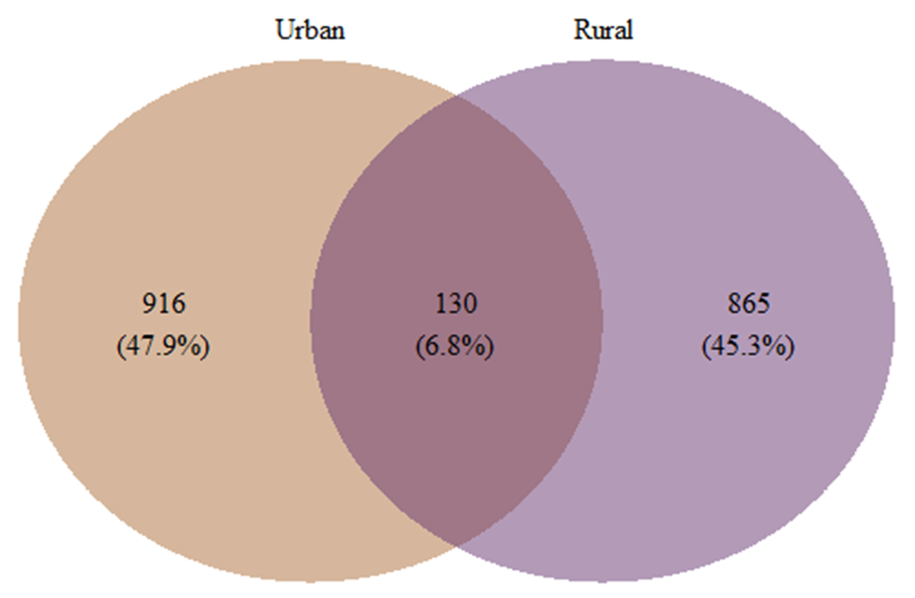
Additional File 4 Figure S2: Venn diagram showing the unique and shared phylotypes for samples collected from urban and rural participants.

