Definitions of landmarks used in this study
Table S1. Definitions of craniometric landmarks used for this study [6, 43].
No | Landmark | Abbreviation | Nature | Definition
1 | Nasion | n | Median | Midline point on the nasofrontal suture.
2 | Mid-nasal | mn | Median | Midline point on the internasal suture midway between nasion and rhinion.
3 | Rhinion | rhi | Median | Most rostral (end) point on the internasal suture. Cannot be determined accurately if nasal bones are broken distally.
4 | Nasospinale | ns | Median | The point where a line drawn between the inferior most points of the nasal aperture cross the median plane. Note that this point is not necessarily at the tip of the nasal spine.
5 | Prosthion | pr | Median | Median point between the central incisors on the anterior most margin of the maxillary alveolar rim.
6/7 | Zygotemporale superior | zts | Bilateral | Most superior point of the zygomatico-temporal suture.
8/9 | Zygotemporale inferior | zti | Bilateral | Most inferior point of the zygomatico-temporal suture.
10/11 | Jugale | ju | Bilateral | Vertex of the posterior zygomatic angle, between the vertical edge and horizontal part of the zygomatic arch.
12/13 | Frontomalare temporale | fmt | Bilateral | Most lateral part of the zygomaticofrontal suture.
14/15 | Frontomalare orbitale | fmo | Bilateral | Point on the orbital rim marked by the zygomaticofrontal suture.
16/17 | Nasomaxillofrontale | nmf | Bilateral | Point at the intersection of the frontal, maxillary, and nasal bones.
18/19 | Mid-infraorbital | mio | Bilateral | Point on the anterior aspect of the inferior orbital rim, at a line that vertically bisects the orbit.
20/21 | Maxilla fronatale | mf | Bilateral | Intersection of the anterior lacrimal crest with the frontomaxillary suture.
22/23 | Nasomaxillare | nm | Bilateral | Most inferior point of the nasomaxillary suture on the nasal aperture.
24/25 | Alare | al | Bilateral | Instrumentally determined as the most lateral point on the nasal aperture in a transverse plane.
26/27 | Piriform curvature | cp | Bilateral | Most infero-lateral point of the piriform aperture.
28/29 | Nariale | na | Bilateral | Most inferior point of the piriform aperture.
30/31 | Zygomaxillare | zm | Bilateral | Most inferior point on the zygomaticomaxillary suture.
32/33 | Supra-canine | sc | Bilateral | Point on the superior alveolar ridge superior to the crown of the maxillary canine.
34/35 | Mid-supraorbitale | mso | Bilateral | Point on the anterior aspect of the superior orbital rim, at a line that vertically bisects the orbit.
36/37 | Ectoconchion | ec | Bilateral | Lateral point on the orbit at a line that bisects the orbit transversely.
38/39 | Medial orbit | mo | Bilateral | Point on the anterior lacrimal crest at the same level as ectoconchion.
40/41 | Orbitale | or | Bilateral | Most inferior point of the orbital margin.
42/43 | Zygoorbitale | zo | Bilateral | Intersection of the orbital margin and the zygomaticomaxillary suture.

Table S2. Starting point and number of landmarks for each hard-tissue sliding matrix [43].
Matrix | Number of landmarks | Starting point | Definition
Left EAM | 46 | porion (left) | Most superior point on the upper margin of the external auditory meatus.
Right EAM | 46 | porion (right) | Most superior point on the upper margin of the external auditory meatus.
Anterior nasal aperture | 136 | rhinion | Most rostral (end) point on the internasal suture. Cannot be determined accurately if nasal bones are broken distally.
Left orbit | 162 | Mid-supraorbital (left) | Point on the anterior aspect of the superior orbital rim, at a line that vertically bisects the orbit.
Right orbit | 169 | Mid-supraorbital (right) | Point on the anterior aspect of the superior orbital rim, at a line that vertically bisects the orbit.
Table S3. Definition of capulometric landmarks used for this study [6, 41, 42, 43].
Matrix | No | Landmark | Abbreviation | Position | Definition
Ears | 1 | Tragion | t' | Bilateral | The notch above the tragus where the upper edge of the cartilage disappears into the skin of the face.
Ears | 2 | Posterotragion | pt' | Bilateral | Most posterior point on the tragus.
Ears | 3 | Otobasion inferius | obi' | Bilateral | Point of attachment of the ear lobe to the cheek.
Ears | 4 | Subaurale | sba' | Bilateral | Most inferior point on the free margin of the auricle.
Ears | 5 | Lobule posterior | lp' | Bilateral | Most posterior point of the lobule where it meets the helix.
Ears | 6 | Postaurale | pa' | Bilateral | Most posterior point on the free margin of the auricle.
Ears | 7 | Posterohelixa interna | phi' | Bilateral | Posterior most aspect of the inner helix margin.
Ears | 8 | Superhelixa interna | shi' | Bilateral | Superior most aspect of the inner helix margin.
Ears | 9 | Superaurale | sa' | Bilateral | Most superior point on the free margin of the auricle.
Ears | 10 | Otobasion superius | obs' | Bilateral | Point of attachment of the helix in the temporal region.
Ears | 11 | Preaurale | pra' | Bilateral | Most anterior point of the ear located just in front of the otobasion superius.
Ears | 12 | Supraconchale | sc' | Bilateral | Most posterior point of the conchal rim where it crosses under the helix.
Ears | 13 | Origohelixa | oh' | Bilateral | Point of origin of the helix from the concha.
Ears | 14 | Antitragion | at' | Bilateral | Apex of the antitragus.
Ears | 15 | Intertragion | it' | Bilateral | Apex of the groove between the tragus and the antitragus.
Ears | 16 | Subanguili conchali | iac' | Bilateral | Inferior angle of the conchal rim.
Ears | 17 | Posterosuperior aurale | psa' | Bilateral | Strongest helical curvature around the midpoint between superaurale and posteroaurale.
Ears | 18 | Supra-anguili conchali | sac' | Bilateral | Superior angle of the conchal rim.
Ears | 19 | Strongest anti-helical curvature | shc' | Bilateral | The most posterior point of the conchal rim.
Eyes | 1/4 | Exocanthion | ex' | Bilateral | Lateral point of the outer corner of the eye fissure.
Eyes | 2/3 | Endocanthion | en' | Bilateral | Most medial point of the palpebral fissure, at the inner commissure of the eye; best seen when the subject is gazing upward.
Nose | 1 | Pronasale | prn' | Median | Most anterior midline point of the nose.
Nose | 2 | Nasale inferius | ni' | Median | Most inferior point of the apex nasi.
Nose | 3 | Columella | c' | Median | Midpoint of the nasal columella crest, intersecting a line between the two columella points.
Nose | 4 | Subnasale | sn' | Median | Most postero-superior midline point of the nasal septum.
Nose | 5 | Sellion | se' | Median | Deepest midline point of the nasofrontal angle.
Nose | 6/7 | External alar curvature | eac' | Bilateral | Most anterior point of the nasal wing at the maximum of the curvature.
Nose | 8/9 | Superior alar curvature | sac' | Bilateral | Most superior point of the nasal wing.
Nose | 10/11 | Alare | al' | Bilateral | The most lateral point on the nasal ala.
Nose | 12/13 | Alar curvature point | ac' | Bilateral | The most posterolateral point of the curvature of the baseline of each nasal ala.
Nose | 14/15 | Mid-nostril | mn' | Bilateral | Midpoint of the maximal nostril width – projected on the transition nostril/philtrum.
Nose | 16/17 | Mid-columella | mc' | Bilateral | Midpoint of the nasal columella crest on either side – where the columella thickness is measured.
Nose | 18/19 | Nasal depth | nd' | Bilateral | Most medial point of the transition nose/eye.
Mouth | 1/2 | Chelion | ch' | Bilateral | Most lateral point of the mouth fissure, where both lips meet.
Mouth | 3 | Labiale superius | ls' | Median | Midpoint of the vermillion border of the upper lip.
Mouth | 4 | Labiale inferius | li' | Median | Midpoint of the vermillion border of the lower lip.
Mouth | 5/6 | Vermillion superius | vs' | Bilateral | Most superior point of the vermillion border of the upper lip at its apex on either side of the mouth.
Mouth | 7/8 | Vermillion inferius | vi' | Bilateral | Most inferolateral point of the vermillion border of the lower lip at the maximum curve change on either side of the mouth.

Reproducibility testing
Table S4. Mean (M) and standard deviation (SD) of the dispersion errors for hard and soft tissue landmarks and hard-tissue sliding landmarks in white South Africans.
 |  | Intraobserver errors |  | Interobserver errors
 |  | M | SD | M | SD
Soft-tissue | Left ear | 0.980 | 0.381 | 1.284 | 0.741
Soft-tissue | Right ear | 0.758 | 0.290 | 1.689 | 0.802
Soft-tissue | Eyes | 0.443 | 0.028 | 1.206 | 0.687
Soft-tissue | Nose | 0.804 | 0.195 | 1.132 | 0.470
Soft-tissue | Mouth | 0.628 | 0.050 | 1.130 | 0.519
Hard-tissue | Midfacial matrix | 0.806 | 0.056 | 1.130 | 0.190
Hard-tissue | Left EAM | 0.849 | 0.049 | 0.357 | 0.196
Hard-tissue | Right EAM | 0.537 | 0.043 | 0.538 | 0.084
Hard-tissue | Left orbit | 2.146 | 0.094 | 1.592 | 0.075
Hard-tissue | Right orbit | 1.004 | 0.043 | 1.486 | 0.131
Hard-tissue | Nasal aperture | 0.323 | 0.122 | 0.853 | 0.249
Dispersion mean values < 2 mm indicate a high level of reliability and repeatability of automatic landmarking. M, mean; SD, standard deviation; EAM, external acoustic meatus.

Table S5. Mean (M) and standard deviation (SD) of the dispersion errors for hard and soft tissue landmarks and hard-tissue sliding landmarks in the French group.
 |  | Intraobserver errors |  | Interobserver errors
 |  | M | SD | M | SD
Soft-tissue | Left ear | 0.945 | 0.256 | 0.741 | 0.217
Soft-tissue | Right ear | 1.034 | 0.220 | 0.900 | 0.252
Soft-tissue | Eyes | 0.632 | 0.081 | 0.391 | 0.050
Soft-tissue | Nose | 0.771 | 0.133 | 0.665 | 0.137
Soft-tissue | Mouth | 0.465 | 0.151 | 0.486 | 0.169
Hard-tissue | Midfacial matrix | 0.990 | 0.137 | 0.900 | 0.133
Hard-tissue | Left EAM | 1.997 | 0.049 | 0.357 | 0.196
Hard-tissue | Right EAM | 1.274 | 0.127 | 1.950 | 0.130
Hard-tissue | Left orbit | 3.362 | 2.061 | 3.261 | 2.153
Hard-tissue | Right orbit | 2.326 | 0.100 | 2.021 | 0.092
Hard-tissue | Nasal aperture | 0.376 | 0.053 | 0.707 | 0.058
Dispersion mean values < 2 mm indicate a high level of reliability and repeatability of automatic landmarking. M, mean; SD, standard deviation; EAM, external acoustic meatus.

Multivariate normality testing
C1 Population affinity variation

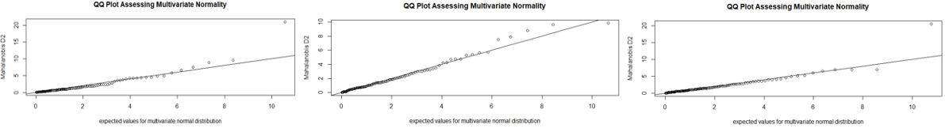
Figure S1. Q-Q plots of the residuals of the linear model for the left ear shape (left) versus population affinity; right ear shape (middle) versus population affinity, and the linear model for the eye shape (right) versus population affinity.

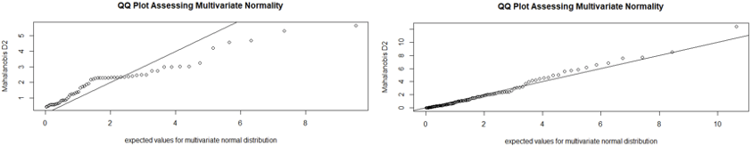
Figure S2. Q-Q plots of the residuals of the linear model for the nose shape (left) versus population affinity, and the linear model for the mouth shape (right) versus population affinity.

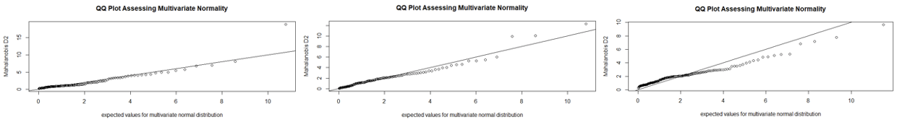
Figure S3. Q-Q plots of the residuals of the linear model for the midfacial matrix (left) versus population affinity; hard-tissue left EAM (middle) versus population affinity, and linear model for the hard-tissue right EAM (right) versus population affinity.

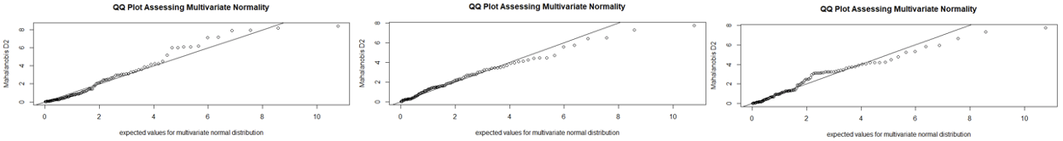
Figure S4. Q-Q plots of the residuals of the linear model for the left orbit shape (left) versus population affinity; right orbit shape (right) versus population affinity, and the linear model for the anterior nasal aperture shape (right) versus population affinity.

C2 Assessment of sex, age, and allometry

Population affinity was observed to be highly significant therefore each ancestral group was assessed separately to minimise the effects of population affinity on the data when assessing the influence of sex, age and allometry.

White South African subsample

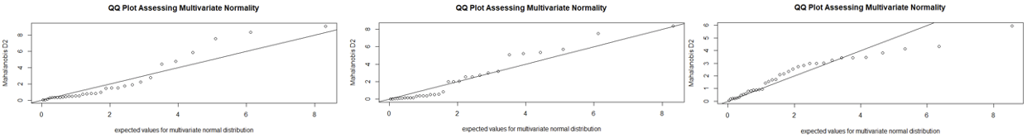
Figure S5. Q-Q plots of the residuals of the linear model for the left ear shape (left) versus population affinity; right ear shape (middle) versus population affinity, and the linear model of the linear model for the eyes shape versus population affinity (right).

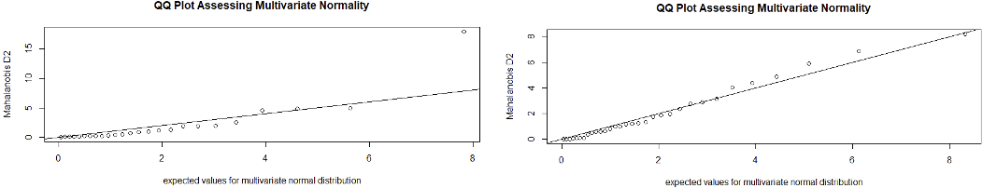
Figure S6. Q-Q plots of the residuals of the linear model for the nose shape (left) versus population affinity, and the linear model of the mouth shape (left) versus population affinity.

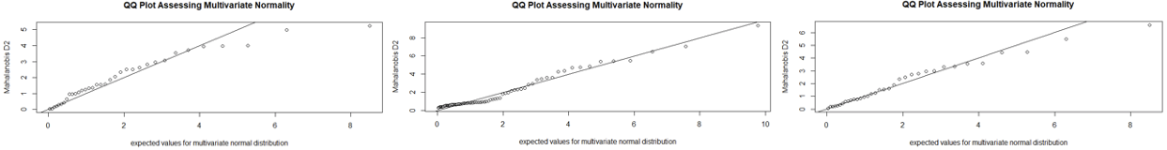
Figure S7. Q-Q plots of the residuals of the linear model for the midfacial matrix (left) versus population affinity; hard-tissue left EAM (middle) versus population affinity, and linear model for the hard-tissue right EAM (right) versus population affinity.
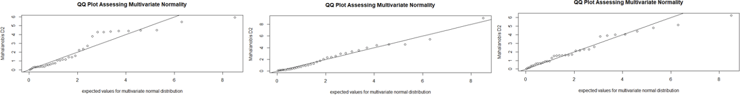
Figure S8. Q-Q plots of the residuals of the linear model for the left orbit shape (left) versus population affinity; right orbit shape (right) versus population affinity, and the linear model for the anterior nasal aperture shape (right) versus population affinity.

French subsample
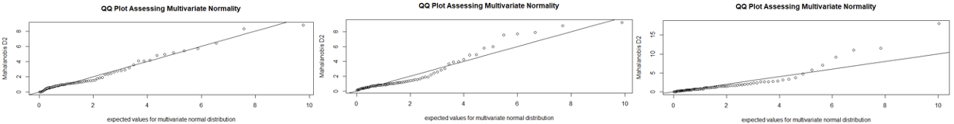
Figure S9. Q-Q plots of the residuals of the linear model for the left ear shape (left) versus population affinity; right ear shape (middle) versus population affinity, and the linear model of the linear model for the eyes shape versus population affinity (right).
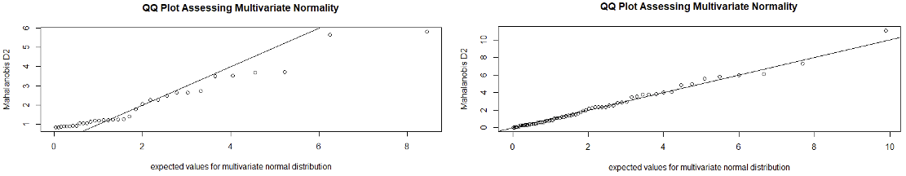
Figure S10. Q-Q plots of the residuals of the linear model for the nose shape (left) versus population affinity, and the linear model of the mouth shape (left) versus population affinity.
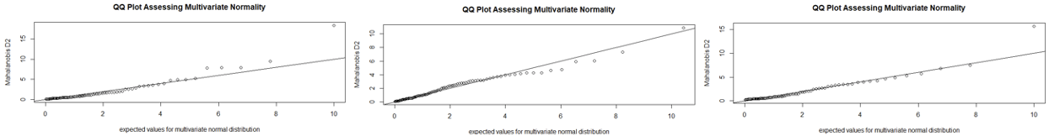
Figure S11. Q-Q plots of the residuals of the linear model for the midfacial matrix (left) versus population affinity; hard-tissue left EAM (middle) versus population affinity, and linear model for the hard-tissue right EAM (right) versus population affinity.

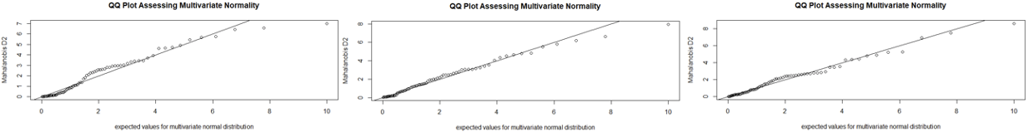
Figure S12. Q-Q plots of the residuals of the linear model for the left orbit shape (left) versus population affinity; right orbit shape (right) versus population affinity, and the linear model for the anterior nasal aperture shape (right) versus population affinity.

Non-significant PCA graphs - shape analysis of hard and soft tissue matrices
D1 Effects of sexual dimorphism on facial matrix shape

White South African subsample

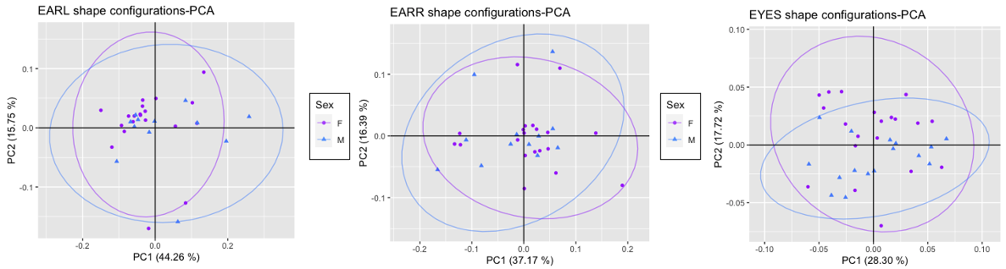
Figure S13. PC 1 versus PC 2 of the white South African sample for sex indicating the maximum and minimum of the shapes of the soft-tissue left ear (left), soft-tissue right ear (middle), and soft-tissue eyes (right) along PC1. F = female; M = male.

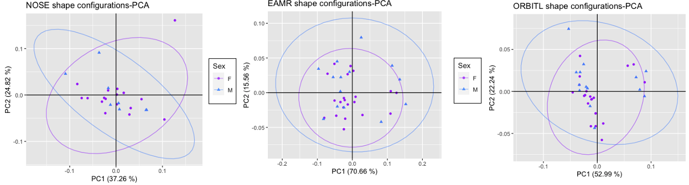
Figure S14. PC 1 versus PC 2 of the white South African sample for sex indicating the maximum and minimum of the shapes of the soft-tissue nose (left), hard-tissue right EAM (middle), and hard-tissue left orbit (right) along PC1. F = female; M = male.

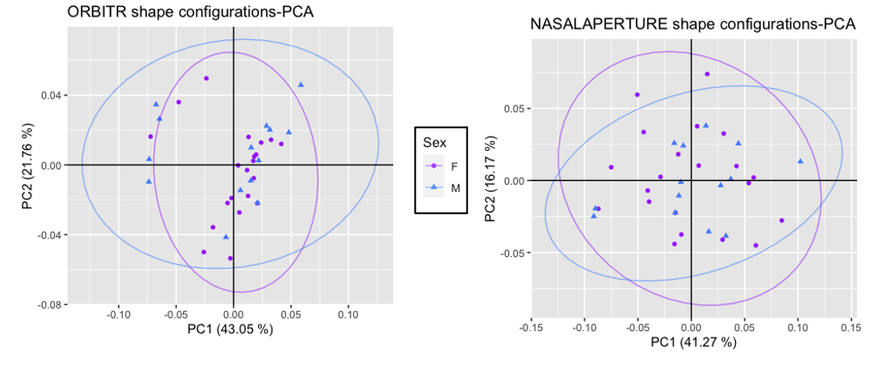
Figure S15. PC 1 versus PC 2 of the white South African sample for sex indicating the maximum and minimum of the shapes of the hard-tissue right orbit (left) and hard-tissue anterior nasal aperture (right) along PC1. F = female; M = male.
French subsample

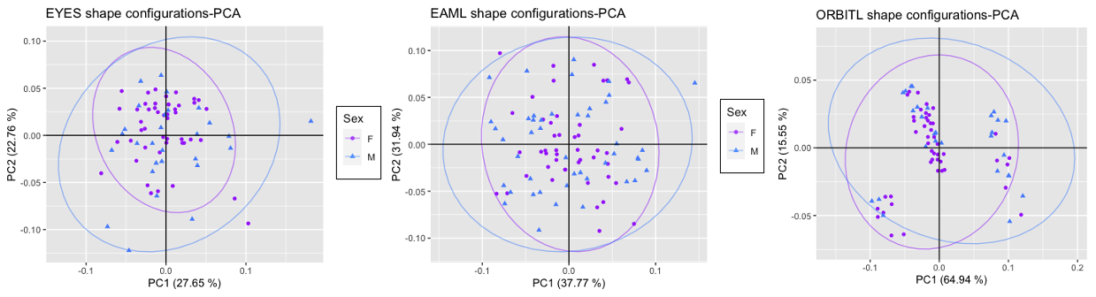
Figure S16. PC 1 versus PC 2 of the French sample for sex indicating the maximum and minimum of the shapes of the soft-tissue eyes (left), hard-tissue EAM (middle), and hard-tissue left orbit (right) along PC1. F = female; M = male.

D2 Effects of age on facial matrix shape

White South African subsample
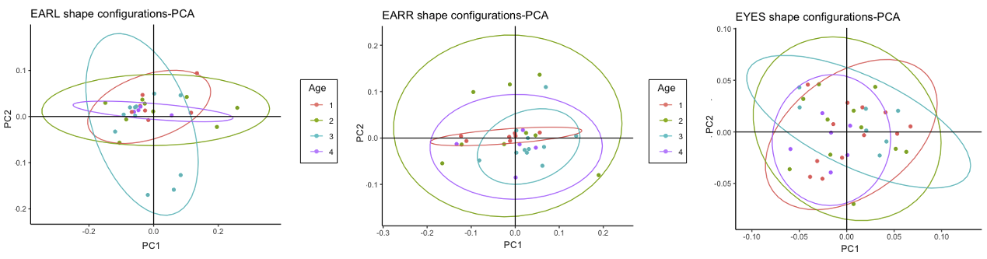
Figure S17. PC 1 versus PC 2 of the white South African sample for age indicating the maximum and minimum of the shapes of the soft-tissue left ear (left), soft-tissue right ear (middle), and soft-tissue eyes (right) along PC1. 1 = 18 – 29 years old; 2 = 30 – 44 years old; 3 = 45 – 59 years old; 4 = 60+ years.

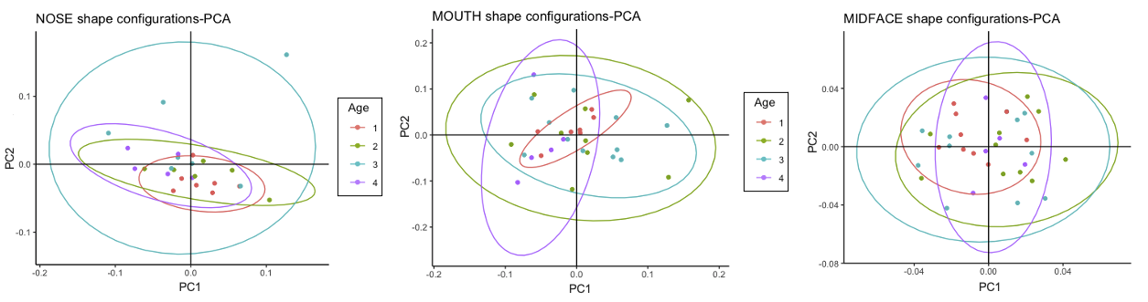
Figure S18. PC 1 versus PC 2 of the white South African sample for age indicating the maximum and minimum of the shapes of the soft-tissue nose (left), soft-tissue mouth (middle), and hard-tissue midfacial matrix (right) along PC1. 1 = 18 – 29 years old; 2 = 30 – 44 years old; 3 = 45 – 59 years old; 4 = 60+ years.

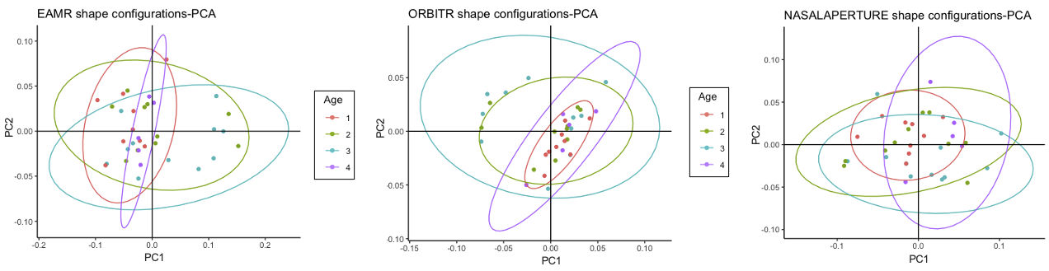
Figure S19. PC 1 versus PC 2 of the white South African sample for age indicating the maximum and minimum of the shapes of the hard-tissue right EAM (left), hard-tissue right orbit (middle), and hard-tissue anterior nasal aperture (right) along PC1. 1 = 18 – 29 years old; 2 = 30 – 44 years old; 3 = 45 – 59 years old; 4 = 60+ years.
French subsample

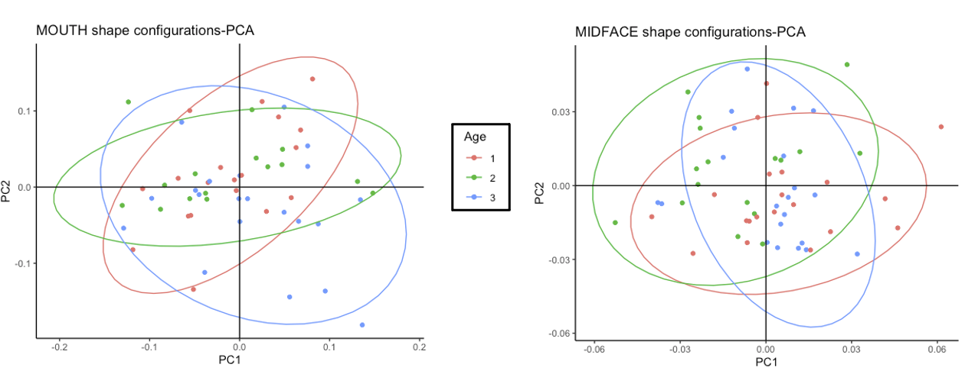
Figure S20. PC 1 versus PC 2 of the French sample for age indicating the maximum and minimum of the shapes of the soft-tissue mouth (left) and hard-tissue midfacial matrix (right) along PC1. 1 = 18 – 29 years old; 2 = 30 – 44 years old; 3 = 45 – 59 years old. .
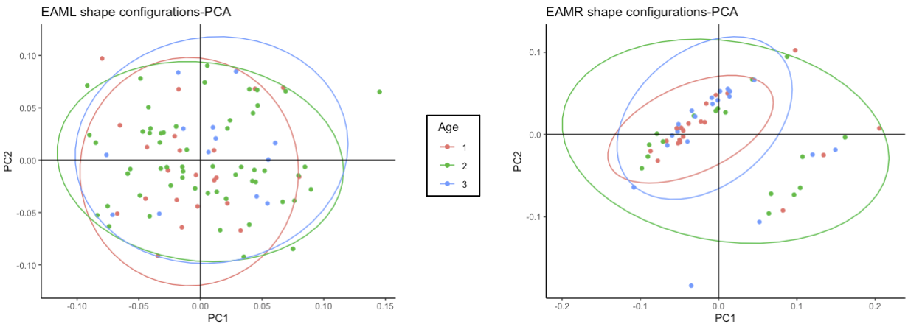
Figure S21. PC 1 versus PC 2 of the French sample for age indicating the maximum and minimum of the shapes of the hard-tissue left EAM (left) and hard-tissue right EAM (right) along PC1. 1 = 18 – 29 years old; 2 = 30 – 44 years old; 3 = 45 – 59 years old.

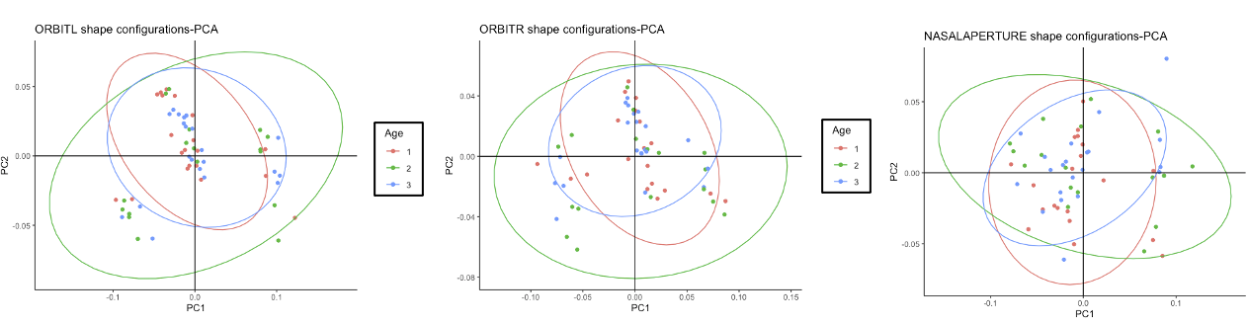
Figure S22. PC 1 versus PC 2 of the French sample for age indicating the maximum and minimum of the shapes of the hard-tissue left orbit (left), hard-tissue right orbit (middle) and hard-tissue anterior nasal aperture (right) along PC1. 1 = 18 – 29 years old; 2 = 30 – 44 years old; 3 = 45 – 59 years old.

