Supplementary information
Table S1. Taxa and NCBI GenBank accession numbers for the taxa used to infer the phylogenies in Figure 4.
Taxon | Voucher ID | 12S Accession | 16S Accession
Proscelotes aenea | EOS144 | SUB13084977 | SUB12872088
Proscelotes aenea | EOS145 | SUB13084980 | SUB12843158
Proscelotes aenea | EOS157 | NA | SUB12843061
Melanoseps occidentalis | S11 | NA | AY217973
Feylinia grandisquamis | F1 | AY218002 | AY217952
Feylinia currori | E62 | AY308369 | AY308220
Mesoscincus schwartzei | JAC_21060 | AY649117 | AY649158
Janetaescincus braueri | - | AY649123 | AY649164
Amphiglossus astrolabi | - | AY391125 | AY391143
Chalcides simonyi | E3007.2 | EU277872 | EU278030
Sepsina angolensis | S13 | AY218024 | AY217975
Scelotes arenicola | S7 | AY218038 | AY217988
Proscelotes eggeli | S22 | AY218032 | AY217982
Proscelotes eggeli | - | NA | AY315561
Chalcides chalcides | - | AJ416936 | AJ416935
Hakaria simonyi | - | AY649122 | AY649163
Scelotes mirus | - | AY649130 | AY649171
Scelotes anguina | S20 | AY218030 | AY217981
Scelotes anguena | - | NA | AY028891
Pamelaescincus gardineri | Chelex1 | AY308437 | AY308285
Scelotes caffer | S4 | AY218035 | AY217985
Scelotes kasneri | S6 | AY218037 | AY217987
Scelotes sexlineatus | S2 | AY218033 | AY217983
Scelotes gronovii | S5 | AY218036 | AY217986
Scelotes montispectus | S17 | AY218027 | AY217978
Scelotes bipes | S18 | AY218028 | AY217979

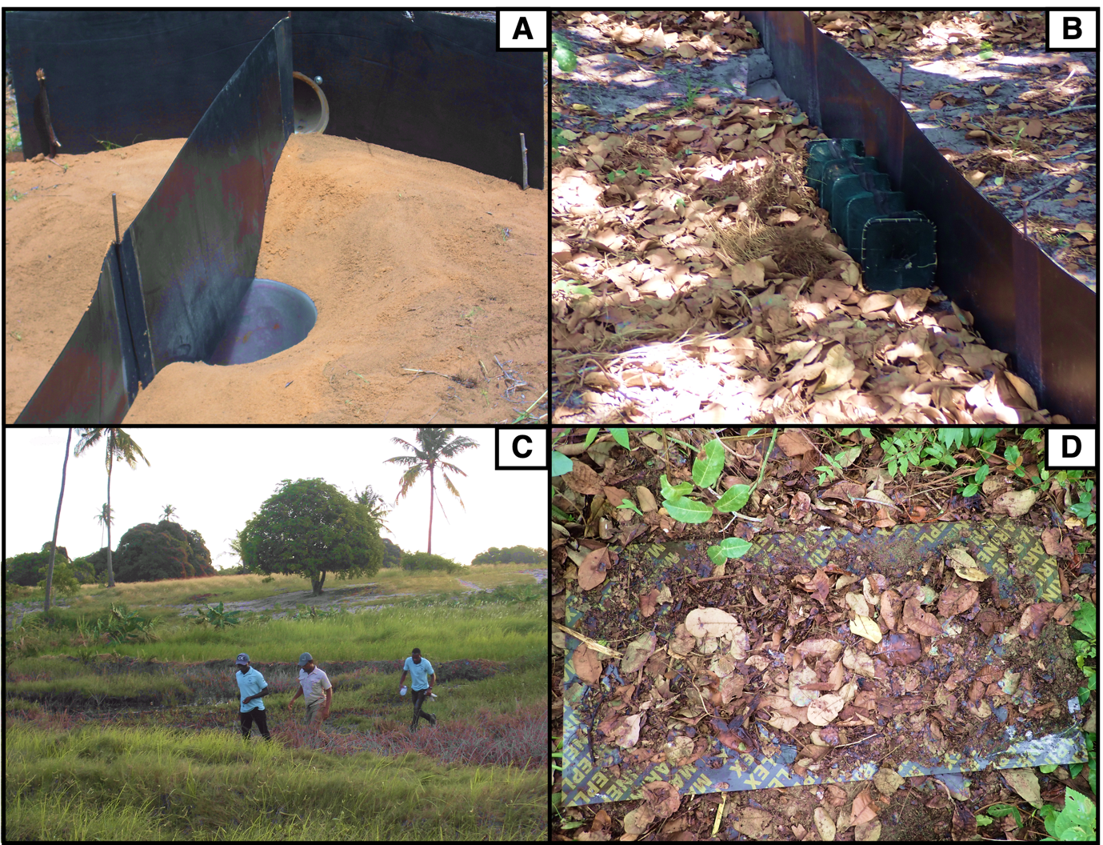
Figure S1: Photographs illustrating the various sampling methods used in the study. A. Pitfall traps with drift fencing, B. Funnel traps, C. Active search (from left to right: A. Jamal, C. Nanvonamuquitxo and W. Monia), D. Artificial refugia.
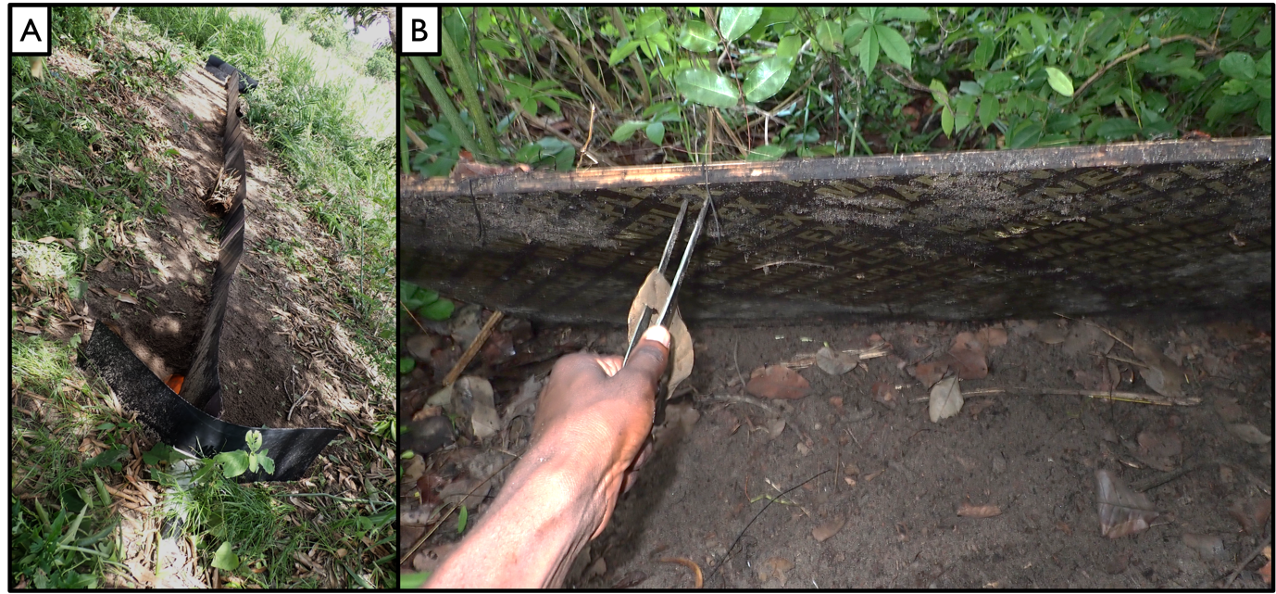
Figure S2: Additional photographs showcasing the trapping system and the thickness of the plywood sheets.

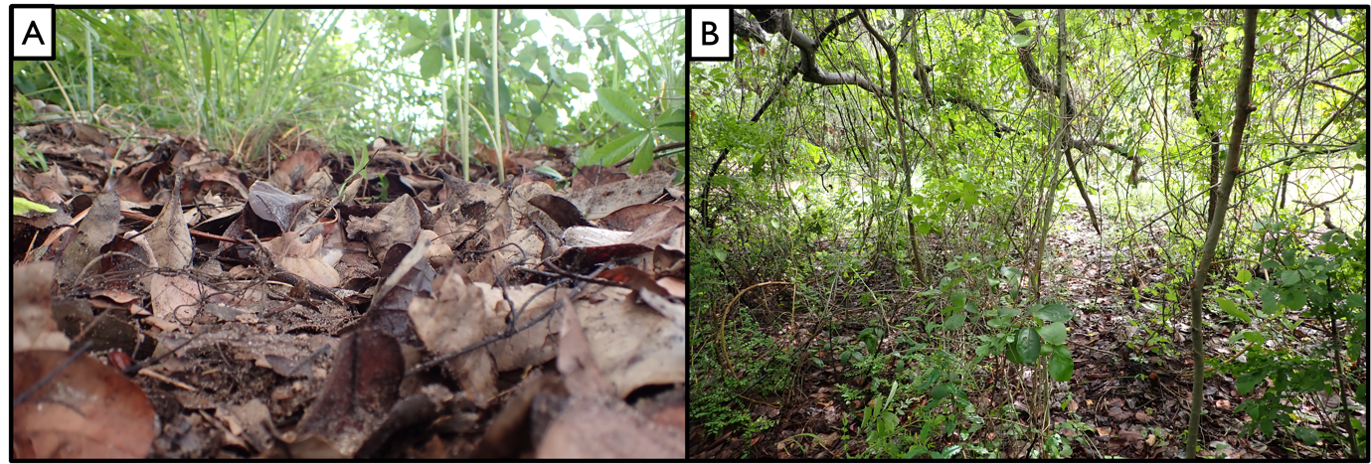
Figure S3: Additional photographs showcasing the habitats where the P. aenea specimens were collected.

Table S2: Comparison of 15 anatomical structures between the colected P. aenea specimens in this study and the ones in 1918.
 | Puruleia et al. 2023 | Barbour and Loveridge, 1928
Toes | Five toes, two of them longer (third and fourth) than double the lengt of the others. | Five toes, two of them longer (third and fourth) than double the length of the others.
Snout | Slightly conical and projected downwards. | Slightly conical and projected downwards.
Supranasal | Two | Two
Frontonasal | One | One
Frontal | One, and double the length of the frontonasal. | One, and double the length of the frontonasal
Prefrontal | Absent | Absent
Infralabials | Six | Not mentioned on the description
Supralabials | Six, with the fifth touching the eye. | Six, with the fifth touching the eye.
Supraocular | Four | Four
Preocular | Two | Two
Postocular | One | One
Frontoparietal | Absent | Absent
Interparietal | One with an triangular shape and with a pineal eye. | One with an angular shape
Parietal | One | Not mentioned on the description
Supraciliary | Six | Six

