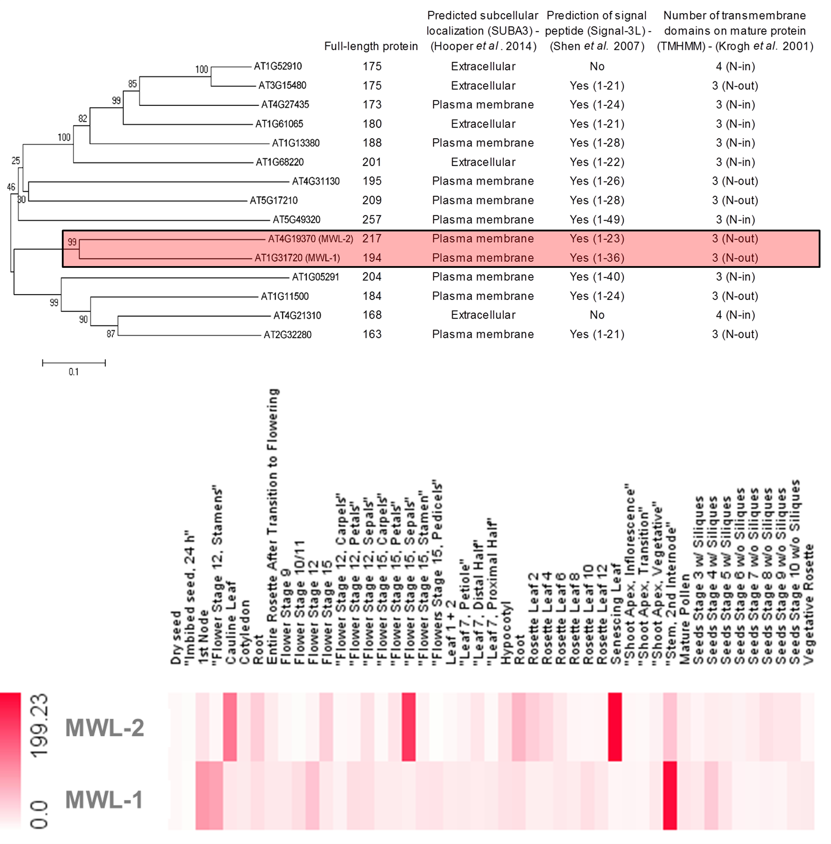
B
A
S1 Fig. Comparative analysis of all members of the Arabidopsis domain of unknown function 1218 (DUF1218) family and expression profiling of the candidate members, MODIFYING WALL LIGNIN-1 (MWL-1, At1g31720) and MWL-2 (At4g19370).
A. Neighbor-joining phylogenetic tree of Arabdiopsis DUF1218-containing proteins. ClustalW was used to align protein sequences from TAIR and the alignment thereafter used to construct the tree using p-distance and pairwise deletion with 1000 bootstrap replicates in MEGA5 [1]. Prediction of subcellular localization, signal peptide and number of transmembrane domains was done using SUBA3 [2], Signal-3L [3] and TMHMM [4] respectively with default settings. Highlighted in pink are the related MWL-1 and 2 sequences. B. Arabidopsis expression profiles for MWL-1 and MWL-2 across different tissues during development, exctracted from The Bio-Analytic Resource for Plant Biology (http://bar.utoronto.ca/welcome.htm) [5]. Preferential expression is seen at distinct developmental stages, however there is overlap in the secondary cell wall depositing, 2nd internode region.

References
1. Tamura K, Peterson D, Peterson N, Stecher G, Nei M, et al. MEGA5: Molecular evolutionary genetics analysis using maximum likelihood, evolutionary distance, and maximum parsimony methods. Mol Biol and Evol. 2011. 28: 2731-2739.
2. Hooper CM, Tanz SK, Castleden IR, Vacher MA, Small ID, et al. (2014) SUBAcon: a consensus algorithm for unifying the subcellular localization data of the Arabidopsis proteome. Bioinformatics. 2014. 30: 3356-3364.
3. Shen H-B, Chou K-C Signal-3L: A 3-layer approach for predicting signal peptides. Biochemical and Biophysical Research Comm. 2007. 363: 297-303.
4. Krogh A, Larsson B, Von Heijne G, Sonnhammer EL (2001) Predicting transmembrane protein topology with a hidden Markov model: application to complete genomes. J. Mol. Biol. 2001. 305: 567-580.
5. Schmid M, Davison TS, Henz SR, Pape UJ, Demar M, et al. (2005) A gene expression map of Arabidopsis thaliana development. Nature Genetics. 2005. 37: 501-506.

