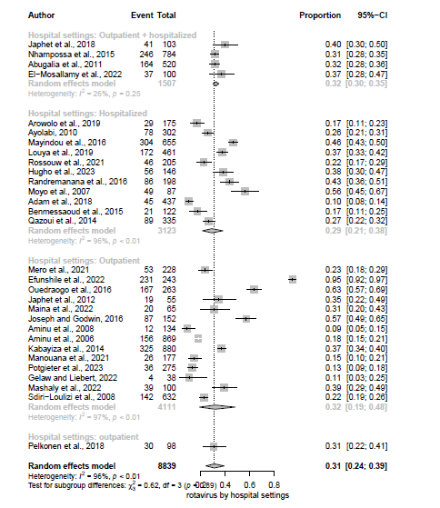
Suppl figure 6: Summary proportion of rotavirus stratified by settings
Suppl figure 7: Summary proportion of norovirus stratified by settings

Suppl figure 8: Summary proportion of adenovirus stratified by settings


Suppl figure 9: Summary proportion of sapovirus stratified by settings

Suppl figure 10: Summary proportion of astrovirus stratified by settings

