System Design for a Frozen Food Company.

by
Karin de Wet
28155344

Project leader: Miss F. le Roux

submitted in partial fulfilment of the requirements for the degree
BACHELORS OF INDUSTRIAL ENGINEERING
in the
FACULTY OF ENGINEERING, BUILT ENVIRONMENT AND INFORMATION TECHNOLOGY

UNIVERSITY OF PRETORIA

October 2012
Acknowledgements

The following people are thanked for their support and help throughout the project:
Mr. D. De Villiers for his willingness to help, as well as his knowledge with the construction of the IS and his over all support regarding the project deliverables
Mrs. F. Leroux, group leader, for her guidance in the development of the project, as well as her value adding critique.

Executive Summary

Frozen -, pre-cooked -, microwaveable -, or simply, RM’s are all names with the same meaning and are what the Birds Eye chief executive refer to, as the future of food (Hall, 2012). DeliciouSavings trades in, what will throughout this document be referred to as, RM’s. The company’s work includes the outsourcing of production of meals, as well as the branding, advertising, selling and distribution of the final products. The current client base is expanding faster than expected and necessary systems need to be put in place in order to handle the expanding demand.

The company has only been established quite recently and therefore has not yet, designed and implemented advanced processes that will support increased demand. Management believes that it will be beneficial to the company if the operating information is captured in an easily manageable system. It was suggested by management that an information system IS) be designed to improve the quality and flow of information, as well as the way it gets captured. Automation of certain processes is also deemed necessary. This can be achieved when a specific process is dependent on information that can be stored on a system.

The aim of the project is to clearly identify problems that the company is experiencing, research possible solutions and choose and implement the best alternative, with the use of engineering strategies. Ideally, the project should aid the company with systems that will secure efficient and effective growth in order to gain a competitive advantage in the market.

Table of Contents

List of Figures iv
List of Tables v
List of Acronyms vi
1. Introduction 1
1.1 Organisational Background 1
1.2 Problem Statement 2
1.3 Problem Definition 2
1.3.1 The use of Information technology 4
1.3.2 Lack of knowledge of IS’s and proper information management 4
1.3.3 Automation 4
1.4 Project Aim 4
2. Project Scope 4
2.1 Information system 4
2.1.1 Information System development 4
2.1.2 Information System Design 4
2.2 Automate Processes through the Information System 4
3. Literature Review 4
3.1 A background on the Frozen Food business. 4
3.2 Information Systems in Practice 4
3.2.1 Information System development 4
3.2.2 Information System design 4
3.2.2.1. Software comparisons 4
3.2.2.2 Information System Summary 4
3.3 Automation of processes within an IS 4
4. System development 4
4.1. System development introduction. 4
4.2 Planning 4
4.3. System Analysis 4
4.3.1 The process flow chart 4
4.3.1.1 Order placement process flow chart 4
4.3.1.2 Inventory level adjustment process flow chart 4
4.3.2 The context diagram 4
4.3.3 The use-case diagram (UCD) 4
4.3.4 Use case narratives 4
4.4 The Entity Relationship Diagram 4
5. System design 4
5.1 System design introduction 4
5.2 Design Limitations and Constraints 4
6. Conclusion 4
7. References 4
Appendix A: User Manual 4

List of Figures

Figure 1 - Company Logo 1
Figure 2 - Fishbone Diagram 3
Figure 3 - Phases of SDLC 4
Figure 4 - Figure indicating the planning phase of the SDLC 4
Figure 5 the analysis phase of the SDLC 4
Figure 6 - Indication of where a need for an IS has been identified 4
Figure 7 - Order placement process flow chart 4
Figure 8 - Inventory level adjustment process flow chart 4
Figure 9 - Context diagram 4
Figure 10 - Description of UCD 4
Figure 11 - Deliveries subsystem UCD. 4
Figure 12 - Order placement subsystem UCD. 4
Figure 13 - Inventory subsystem UCD. 4
Figure 14 - IS management subsystem UCD. 4
Figure 15 - SR payment subsystem UCD. 4
Figure 16 - UC narrative features 4
Figure 17 – ERD 4
Figure 18 - Figure indicating the design phase of the SDLC. 4

List of Tables

Table 1 - Operating system support comparison 4
Table 2 - Fundamental features comparison 4
Table 3 - Adjust inventory levels according to losses Narrative 4
Table 4 - Identify SR with order narrative 4
Table 5 - Propose distribution point stock order narrative. 4

List of Acronyms

DFD | Data Flow Diagram
ERD | Entity Relationship Diagram
IS | Information System
IT | Information Technology
LDPM | Local Distribution Point Manager
MS | Microsoft
PHP | Hypertext Pre-Processor
RM | Ready Meal
SCD | System Context Diagram
SDLC | System Development Life Cycle
SQL | Structure Query Language
SR | Sales Representative
UCD | Use Case Diagram
UI | User Interface

Introduction

1.1 Organisational Background

DeliciouSavings has twenty seven ready meals on the company menu, constituting of a big product variety including categories like side dishes, chicken, beef, vegetarian dishes, soups and desserts. A ready meal (RM) can be described as a meal that has been fully prepared and frozen. It can be heated by means of a microwave, stove, oven or other heating methods. The meal can be consumed after it has been heated for the appropriate amount of time.


Figure 1 - Company Logo

The company outsources the production of their meals. Immediately after a meal has been prepared, it will be frozen before any other operations commences. Branding, advertising, selling and the distribution of these products are inbound operations and complete the logistical chain of the company. For these reasons, DeliciouSavings can be considered as a company with a relatively large logistical chain. Due to this and a big product variety, the company deals with a large number of stakeholders and role players. Therefore a lot of information regarding products, suppliers, clients and more will be stored and should be available when required. Currently DeliciouSavings only uses manual processes.

1.2 Problem Statement

Various problems can be identified at the RM company (DeliciouSavings). The company is still in a phase of development and therefore did not show a need for advanced process implementation until recently. Furthermore, a great variety of problems can be a result of a lack in information management, or more importantly, that none of the processes regarding the use of information in specific, has been automated. Finally, information is currently not available in a presentable way that can aid management in decision making. This is necessary considering the current and possible future growth and expansion of the company.

If the company continues to use only manual processes without the aid of Information Technology (IT) and other simplified systems, it will not be able to maintain a continuous increase in growth. This leaves space for improvement. In order to ensure the effective use of information and an increase in the productivity of the company’s processes, an investigation regarding potential solutions need to be performed.

1.3 Problem Definition

The client base is expanding and at a faster rate than expected. Information including customer information, their orders and information linked to orders, such as supplier’s information are gathered and required in other processes. With an expanding client base, more of this information is required. The same applies to the information regarding the increased movement of inventory. To keep track of information in an organised and fast manner is getting increasingly more difficult.

The fishbone diagram in Figure 2 depicts problems that DeliciouSavings is experiencing as well as the cause thereof. Management is aware of most of the problems in the company and believes that it can be attributed to the fact that the company is still in the development phase of business and not yet established. The fact that DeliciouSavings is still in a phase of development, might be the root cause that leads to numerous problems, which are being highlighted as the company is expanding. These individual problems are related in terms of the root cause.

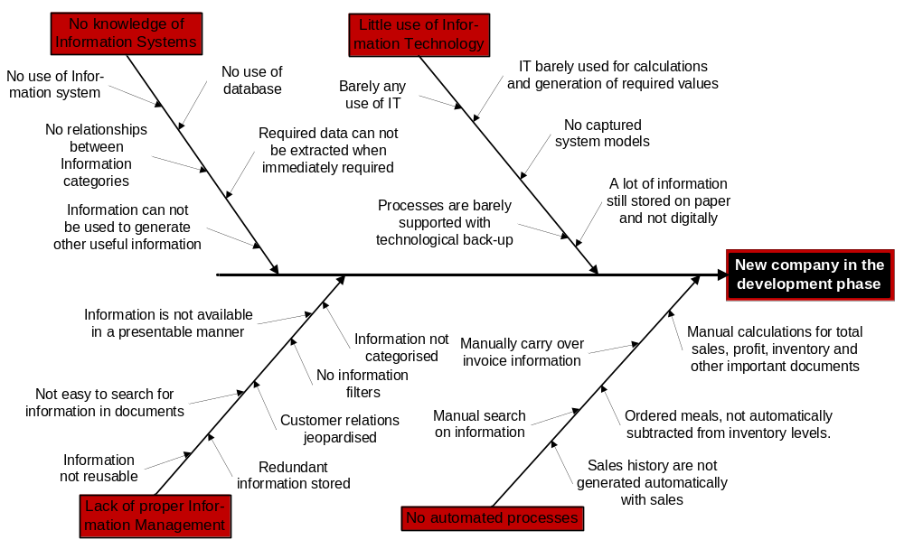
Figure 2 - Fishbone Diagram
Figure 2 – Fishbone diagram

1.3.1 The use of Information technology

The first problem discussed from the fishbone diagram in Figure 2 is the fact that little or no use is made of IT within the company. IT is barely used for calculations of values, as well as the generation of information with the use of other information. A lot of information is still stored on paper and not digitally. Very few processes in the business are not conducted manually, which means that technology is barely being used in their processes.

With the use of IT, a large number of processes within the company system can be simplified and value added to the system. IT forms a major part of businesses today and companies can benefit drastically by using the available technology. With the use of IT, information can be stored and available for use, in other areas, where information is required. The information is also available in digital form which means that the information can easily be copied, carried over, re-used, formatted, edited and more. As part of IT, an IS can be used as a dynamic tool in business.

1.3.2 Lack of knowledge of IS’s and proper information management

In the fishbone diagram, the lack of knowledge of information systems and proper information management are depicted in the diagram as two individual problems, but will be discussed in terms of one problem. In the business essence; these two problems are closely related and similar. The fact that the company owners have a vast understanding of Information systems has restricted them to implement such a system and utilise the benefits thereof. This limitation has also caused them to not be able to manage their information, in the simple way that an information system offers users to manage their information. Both of these reasons boil down to the root cause since the company is new and did not yet implement systems that would be a solution to these problems. Numerous benefits could be experienced by the company with the implementation of an IS since IS’s plays an important role in businesses today. ”Computers and IS’s are essential parts of every business today” (Locke, 2008).

Even though the company owners do not consist of a lot of knowledge concerning the use of IS’s, they are aware of the existence of it and certain benefits it offers. An IS has not yet been implement at the company. With the growth of the company, the need for an IS has increased as the problems depicted in the diagram, arose.

Management are aware of these problems and find that the company are struggling without the use of an IS that can assist them in managing their information. Data and Information are not stored in an organised manner and no relationships are currently available between different categories of information. In more basic terms, there are currently no organised storage of any information regarding customers, their orders, meals, inventory, sales, orders, suppliers and more. Without being able to store this information in an organised manner, automation of processes regarding this information will not be easy.

1.3.3 Automation

When the production of food is outsourced, difficulties occur. Numbers of meals that need to be ordered are calculated manually by adding numbers of orders with the number of meals DeliciouSavings wish to store as inventory. This process is time consuming and tedious. In addition to the inventory problem, when orders are made, no automatic process subtracts the ordered number from inventory. No system supports the physical flow of products with reliable information. This causes staff to physically count meals by hand. This is not easy considering the fact that the meals are frozen, especially when freezers are fully stocked. This is also not a hygienic practice, nor is it an efficient way to collect information regarding the inventory levels.

A great amount of time is spent practising a manual system as discussed here. Some examples also include manual calculations of total sales, sales history, customer invoices and more. None of these are generated automatically with sales data. Without solving the proplem discussed in 1.3.3, solving this problem might be difficult, since the lack of knowledge of IS’s and proper management of information, will result in information not being available for automation.

1.4 Project Aim

The project aims to solve the four problems as discussed in the project definition. With the clear identification of these problems the company is experiencing, possible methods to solutions should be analysed in a literature study. With a thorough understanding of the problem and the defined boundaries of the project scope, the best possible solution, should be chosen and implemented with the use of engineering strategies. Ideally, the project should aid the company with systems that will secure efficient management, which will support effective growth, to gain a competitive advantage in the market.

Project Scope

With the project scope, the deliverables and boundaries will be defined in terms of the requirements identified in the problem statement in order to achieve the aim of this project.
Since the use of an IS will solve the problems experienced with the lack of use of IT, the project scope will only be discussed in terms of the problem, starting at the lack of knowledge of information systems and information management as discussed in section 1.3.2.

2.1 Information system

2.1.1 Information System development

This involves the development of a data base that will store and capture information relative to the company’s operations. This will help to improve client services, save time and ultimately increase productivity. In order to design the IS and its deliverables, the development thereof should be done via diagrams and Industrial Engineering tools that will be discussed in the Literature review.

2.1.2 Information System Design

An IS needs to be designed in order to store information in an organised manner under different categories. There should be a clear relation between the different categories of organised information. This will be used to retrieve data and information in a simplified manner. The system need to be designed, so that any information, relative to the company, can be stored and utilised dynamically. DeliciouSavings should be able to process more orders without having to do redundant and time consuming work and thereby improving productivity. Categories of organised information should include customers, orders, order history, products, ingredients, recipes, inventory and sales agents.

Automate Processes through the Information System

By using the IS as a tool, the relationships between the different categories of information should be used to generate other useful information. As discussed at the problem definition, invoices and shopping lists are not generated automatically. The same applies to the inventory levels that are not adjusted automatically after orders have been made. An inventory model can be considered. A solution must address the problems found and assist DeliciouSavings in carrying a bigger order load. This solution must be simple, effective, efficient and user friendly.

Literature Review

3.1 A background on the Frozen Food business.

Due to increasing time pressure on consumers, as well as nutritional awareness and an appetite for meals that smell and taste like they were cooked at home, a generation are being created where the use for good quality RM’s are increasing. Nowadays, people are working longer hours and in most families, both parents work away from home. Yet chores around the house are still just as time consuming. For this reasons, consumers have become less tolerant of delays. They want what they want, when they want it and they want it right. This causes a positive environment for a demand for RM’s. For this reason DeliciouSavings should have certain support systems implemented in order to help them capture this market.

Companies that have attempted RM or frozen food companies are included in the following paragraph. One of these companies is called Amy’s Kitchen, which was established during the 1980’s and focussed on the production of organic and natural meals. “The company has shown dramatic expansion in its product range in the 22 years since its founding from its one initial vegetable pot pie and in the fiscal year 2008, recorded revenues of 240million USD” (House, 2009). Many more of these companies have been found throughout the world, like Birds Eye for instance, especially in first world countries like America and Europe. “There are several divisions of Birds Eye across the United States and in Europe” (Datamonitor, 2004). Even though it is still a relatively new concept in South Africa, it shows great potential, just as Amy’s kitchen has proven. “The company has grown into the leading natural frozen Food brand in the US” (House, 2009).

An industry profile was conducted by DATAMONITOR, on frozen food companies in Italy. “The performance of the market is forecast to follow a similar pattern, with an expected CAGR of 3.2% for the five-year period 2007-2012. This is anticipated to drive the market to a value of $2.8 billion by the end of 2012” (Datamonitor Plc, 2008).

The Birds Eye company is currently attempting to increase the awareness of its brand, while also providing information about frozen food, through media, as well as the company’s website. “It will provide Birds Eye with data assessing brand awareness before and after the campaign. The chief objective of the scheme is to coerce consumers to the Birds Eye website.” (Datamonitor, 2004). Included in the DelicioSavings’s logistical chain, is advertising and branding. This is important in any company, independent of the size, and the attempt to increase awareness should always be pursued. For future reference, the company can consider making a possible IS web based and integrating it with a company website. This can be used to create brand awareness.

More success stories can be mentioned and the possibilities in the RM market can be discussed, but for the scope of this project, only the discussion on the importance of what will be required to establish DeliciouSavings will follow. The most important aspect of this project with regards to the project aim is to aid the company with systems that will secure efficient management, which will support effective growth, to gain a competitive advantage in the market. This shifts the focus of the project to the possibility of an IS as the second problem discussed in the problem definition in section 1.3.2.
To Amy’s Kitchen’s marketing

Information Systems in Practice

Databases were created for company’s who owned the biggest market share. “Created using 250,000+ industry interviews and consumer surveys and supported by analysis from industry experts using highly complex modelling & forecasting tools, Data monitor’s in-house databases provide the foundation for all related industry profiles” (Datamonitor Plc, 2008).

Taking in consideration the growth in the industry as well as the fact that a database was used in the companies studied, shows the importance of the use of an IS when growth is planned.

Almost all organizations, no matter their scope or size are dependent on IS’s to some degree. “As systems, networks, and software have become more powerful, their abilities to assist us in business have become quite vast. For some small organizations, these systems may not be crucial, but they help to improve the work flow and increase the turnaround of the products to the customer” (Mills, 2011).

DeliciouSavings is also a company that can benefit from the use of an IS, since the IS can help to improve the flow of work and increase turnaround of the products sold to the customer.

Information System development

A model driven approach will be taken in the design phase of the IS. “A model driven design can be defined as a system design approach that emphasizes drawing system models to document, technical and implementation aspects of a system” (Georgiadis, 2005) Diagrams, drawn system models and tools may be useful when designing the IS. Each of these graphs, diagrams or tools will be defined and the reason for each to be used will be discussed.

- Microsoft Visio for the conceptual design of the Information System

Microsoft (MS) Visio can be defined as a drawing and diagramming program for Windows from MS that includes a variety of pre-drawn shapes and picture elements that can be dragged and dropped onto the illustration. Users can define their own elements and place them onto the Visio palette. The Visio package is part of the MS Office brand.

Even though other drawing and diagramming programs are freely available, MS Visio is the chosen program to be used to draw the graphs required for the project, since the student is best acquainted with MS Visio.

- Use Case Diagrams (UCD)

Copeland defined the UCD as follows. “A use case is a scenario that describes the use of a system by an actor to accomplish a specific goal. An actor is a user playing a role with respect to the system. Actors are generally people although other computer systems may be actors. A scenario is a sequence of steps that describe the interactions between an actor and the system. The use case model consists of the collection of all actors and all use cases” (Copeland, 2009)

By using the UCD, role players and actors can be identified, as well as the relationship between them that can be described with a sequence of steps.

- Data Flow Diagrams (DFD)

“A data flow diagram (also called a process model) can be utilized by anyone in any job application. Its use is not necessarily confined to the field of computer science, although it's commonly used in that field. Data can refer to any information or physical entity, such as people. As such, any "data" which "moves"--whether from one physical location to another or from one process to another--can have its movement charted (or tracked) via a DFD. A simple example for using a DFD would be tracking a package from its point of origin to its destination. DFD’s like many organizational tools, are simply tools which are drawn out visually. They are similar to, but different from, flowcharts” (Donahue, 2009).

A DFD is used, in this project; to help map the processes the different entities follows, so that an understanding of the work can be developed. This is useful in the development phase of an IS.

- Entity Relationship Diagram (ERD):

“An ERD diagram is a specialized graphic that illustrates the relationships between entities in a database. ERD often use symbols to represent three different types of information. Boxes are commonly used to represent entities. Diamonds are normally used to represent relationships and ovals are used to represent attributes” (Chapple, 2012).

The ERD is one of the most useful tools in the development of an IS. All the entities, the information that needs to be stored about each entity, as well as the relationships between them are established when an ERD is drawn. With the use of an ERD, relationships such as the relationship between inventory and order placement, can also be determined. This makes the use of an ERD critical.

Information System design

“With the help of IS technology, a company can become competitive in all phases of its customer relationships. The customer resource life cycle model makes it possible for such companies to determine not only when opportunities exist for strategic applications, but also what specific applications should be developed” (Learmonth, 1984).

DeliciouSavings, just like any other company, wants to be successful and competitive in all phases of business, including customer relations. Therefore necessary effort to design an appropriate IS is required. “In order to design, construct and eventually implement an IS, one must first identify, analyse, and understand the stakeholders and user requirements (Bentley and Whitten,2007).”

Different IS’s software is available in practice, some of which will be discussed in aid of deciding which software to use in the design of an IS for DeliciouSavings.

i. MySQL

MySQL, pronounced either "My S-Q-L" or "My Sequel," is an open source relational database management system. It is based on the structure query language (SQL), which is used for adding, removing, and modifying information in the database. Standard SQL commands, such as ADD, DROP, INSERT, and UPDATE can be used with MySQL.

“MySQL can be used for a variety of applications, but is most commonly found on Web servers. A website that uses MySQL may include Web pages that access information from a database. These pages are often referred to as "dynamic," meaning the content of each page is generated from a database as the page loads. Websites that use dynamic Web pages are often referred to as database-driven websites” (PC.net, 2012).

Many database-driven websites that use MySQL also use a Web scripting language like (Hypertext Pre-Processor) PHP to access information from the database. MySQL commands can be incorporated into the PHP code, allowing part or all of a Web page to be generated from database information. Because both MySQL and PHP are both open source (meaning they are free to download and use), the PHP/MySQL combination has become a popular choice for database-driven websites.

ii. Oracle

“Oracle is the world's leading supplier of software for information management but it is best known for its sophisticated relational database products (notably Oracle9i), which are used in Fortune 1000 corporations and by many of the largest Web sites. Oracle's relational database was the world's first to support the Structured Query Language (SQL), now an industry standard. When CEO Lawrence J. Ellison and a few associates formed Oracle in 1977, they were out to prove wrong the prevailing theory that relational databases could not be commercially viable. As proof of their success, they parlayed an initial $2,000 investment in the company into an annual revenue exceeding $9.7 billion” (Kruggel, 2000).

iii. MS Access

“Access is a database tool for gathering and understanding all your information—your phone numbers, inventory, guest lists, whatever you’re tracking—and providing a convenient way to enter, navigate, and report out your data” (Microsoft, 2012).

MS Access is an information management tool that helps you store information for reference, reporting, and analysis. MS Access can help you overcome the limitations found when trying to manage large amounts of information in MS Excel or other spreadsheet applications. The project scope states that information should include information generated from other information. With MS Access, this is possible through queries, forms and reports.

3.2.2.1. Software comparisons

The following tables provide information regarding the three different programmes discussed.
Operating system support
MS Access | Windows | Mac OS X | Linux
MS Access | Yes | No | No
Oracle | Yes | Yes | Yes
MySQL | Yes | Yes | Yes
Table 1 - Operating system support comparison

A disadvantage about MA is that the Mac OS X and Linux operating systems do not support MA. Fortunately, all the computers at DeliciouSavings use the Windows operating system. Windows is the preferred operating system at DeliciouSavings.
Fundamental features
 | Maximum  database size | Referential integrity |  | Transactions | Unicode
MS Access | 20 GB | Yes | Yes |  | Yes
Oracle | Unlimited | Yes | Partial |  | Yes
MySQL | Unlimited | Partial | Partial |  | Yes
Table 2 - Fundamental features comparison

The maximum database size of a MS Access database is 20 GB. With the current size and growth of the company, the maximum size of the database will not be reached within the near future. In case of such a scenario, MS Access allows for the programming of the IS to be exported in SQL.

3.2.2.2 Information System Summary

Ultimately, MS Access is the program that will be used for the design of the IS for DeliciouSavings. The reason being, that the student is acquainted with the software and time constraints limits the ability to learn to use other software solutions.

Automation of processes within an IS

In the sense of this report, automation of processes rather refers to processes that require an output from information, which is generated with the input information, or simply the automation of processes specifically in an IS. This output should be available to the user in a form that is useful. In some cases a simple addition or subtraction of values, by the system, will be sufficient to solve the problem. In MS Access, this is possible with the use of forms, reports and queries or even data access pages, macros and modules. In order to generate an invoice as an output, information will be gathered from the different information categories, or simply tables, with a query. With the use of a query required information will automatically be drawn from the relevant tables and the required output will be provided.
“The Access 2010 database lets you track orders, products, invoices, inventory, and other data associated with running a business that sells goods” (Microsoft, 2012).

With all the information stored on the IS of choice, the inventory levels can automatically be adjusted in accordance to the physical flow of the product. MS Access provides users with the ability to automate almost any processes associated with inventory. Numerous templates are available that can assist companies automate certain processes, including processes regarding inventory, within the companies IS. One of the templates available for inventory is called the goods database template.

“The Goods database template provides automatic tracking of inventory; whenever an order is shipped, or new products are purchased, the database automatically updates the inventory so that you know how much stock you have on hand at any time. The database will also display products that need to be reordered, based on thresholds you specify” (Microsoft, 2012).

4. System development

4.1. System development introduction.

System development is the procedure one follows in the construction and modification of an IS. Different methods and modelling designs are used in the development of an IS. Many of these methods and modelling designs include software development methodologies and it forms the basis for planning and managing the conception of an IS.

System development is of much importance in the development of an IS. A System development Life Cycle (SDLC) supports business priorities in a company. This system development approach can provide a course of activities for the design of the IS and assist the project team in approaching the task of developing an IS. It consists of a set of steps or important phases for designers, which includes the following.

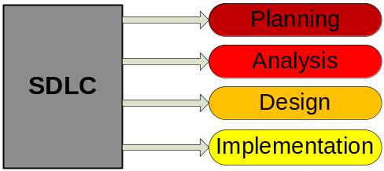
Figure 3 - Phases of SDLC

4.2 Planning

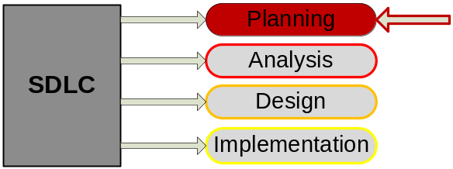
Figure 4 - Figure indicating the planning phase of the SDLC

Planning as one of the SDLC phases is important in the development of the IS. Planning of the project included the project introduction, project scope and literature study. With the first three sections of this document, planning of this project was conducted. With the introductory section, information regarding the organisation was collected, the problems identified and a project aim was defined. With the project scope, the framework for requirements for the different facets of the project could be established. The literature review provided the project team with an overview of the frozen food business, on what can be done, and what popular methods are used when designing an IS. The research was necessary to ensure that the IS, designed, and eventually built, will be up to industry standards.

A top down approach was applied, throughout the previous sections of this document, to analyse the system and understand the operations in the company. This approach focused on obtaining a holistic view of the system before concentrating on a specific section. Greater detail on different sections of the system will be discussed under the analysis phase of the SDLC.

The system development section is included in this document to stimulate logical thinking, by understanding the different subsystems, in order to design an IS that adjusts accordingly to the system as a whole.

4.3. System Analysis

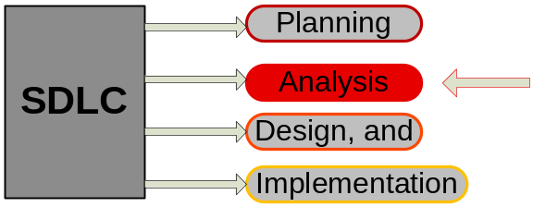
Figure 5 the analysis phase of the SDLC

The aim of the analysis is to determine the problems in the system and to attempt fixing it. This step involves analysing the situation by breaking down the system into subsystems, so that what needs to be designed could be determined. An attempt was made to involve the users of the system, so that correct and exact requirements could be defined. This phase of systems development is very important and it is crucial, since the defining of incorrect and insufficient requirements might lead to a suboptimal or ineffective IS. By defining user requirements correctly, the inappropriate usage of time in the design of the IS was prevented.

Regular meetings were held with the company owners and the business operations were studied in order to identify, analyse and understand the stake holders and user requirements. To verify that the proposed system was designed according to the system requirements, regular update meetings was held throughout the development and design of the system. The design of the system will be discussed in greater detail later in this document.

The following system models were constructed to clearly define the functional requirements of the proposed IS.

- Process flow charts
- Context diagram
- UCD’s
- Use case narratives
- ERD

4.3.1 The process flow chart

The process flow charts were constructed in order to gain an understanding of the processes and procedures within the company, so that needs could be identified as to where an IS can be beneficial to the company. This can assist in the design of the IS, since the system will be developed according to the business operations. It is important for the flow of information to integrate with the physical flow of items and operations in the company.

Two process flow charts were constructed on the flow of operations before an IS has been implemented. These diagrams include:
- Order placement process flow
- Inventory level adjustment process flow

Certain areas in the process flow chart were identified as areas where an IS is required. These areas are indicated with an orange circle on top of the process, decision or termination blocks.

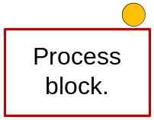
Figure 6 - Indication of where a need for an IS has been identified

4.3.1.1 Order placement process flow chart

Even though this process flow is mainly concerned with the flow of operations when orders are made by customers, the organisational flow regarding order deliveries and Sales representative (SR) payments are also included in figure: 7.

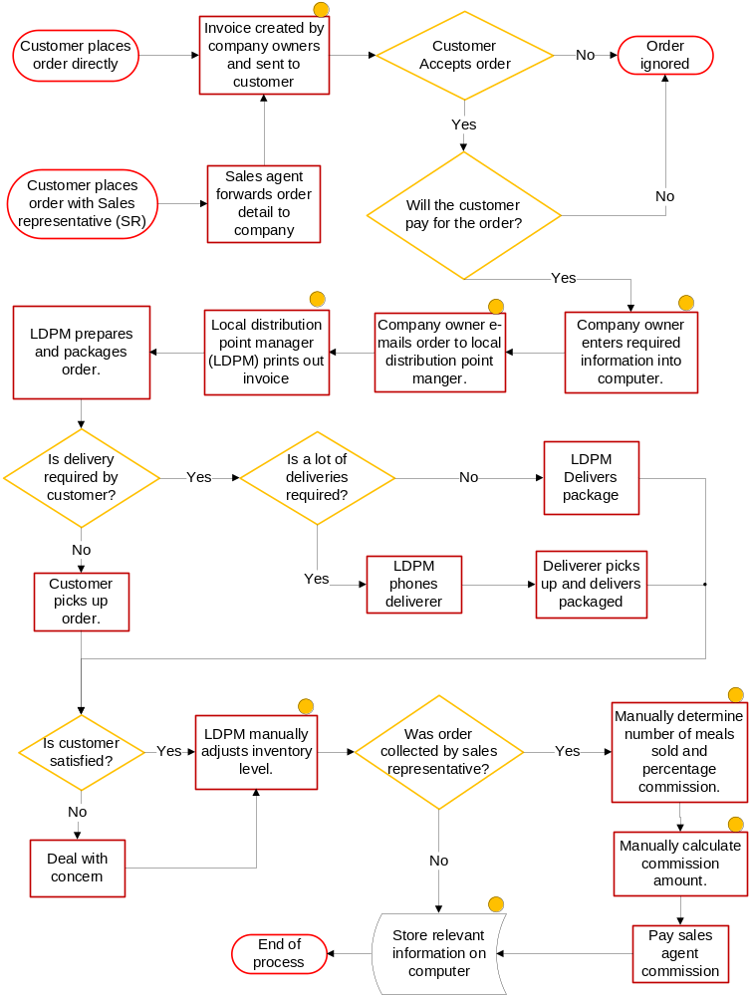
Figure 7 - Order placement process flow chart

4.3.1.2 Inventory level adjustment process flow chart

The process flow in Figure: 8 indicates the flow of operations regarding inventory in the system, as well as the adjustment of the levels thereof. In this process flow, many manual operations are involved. This is time consuming and redundant and creates a need for improvement. By the use of the process flow diagrams, areas where improvement are required and how it is required, has been identified. This highlights, once again, the importance of the development phase.
Mentioned in the diagram, is a predetermined value. The pre-determined inventory level values are determined by management based on the freezer space and the product turnaround time or demand and this is set values. This is also the ideal inventory levels management wishes to keep. This keeps holding costs per item to the minimum.

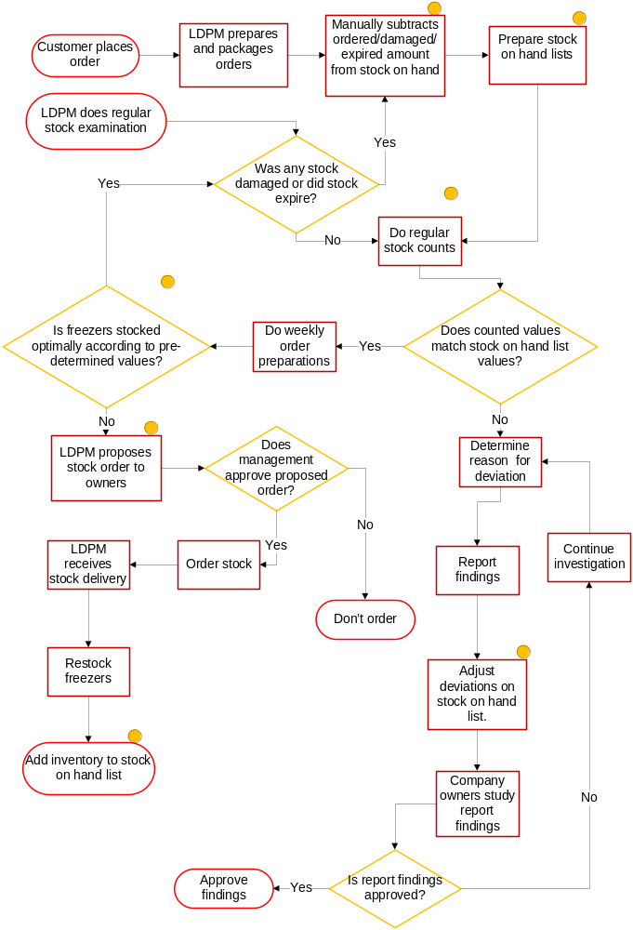
Figure 8 - Inventory level adjustment process flow chart

4.3.2 The context diagram
A System Context Diagram (SCD) in software engineering and systems engineering is a diagram that represents the actors outside a system that could interact with that system. This diagram is the highest level view of a system. It is similar to a Block diagram. SCDs show a system, often software-based, as a whole and its inputs and outputs from/to external factors.
The purpose of the context diagram in this project is to assist the project team in focussing their attention on the external factors involved in the system, as well as events that should be considered in constructing a set of system requirements and constraints. External factors to the system include the actors outside the system that interacts with the system. The diagram assisted in identifying the actors involved and helped the project team gain a high level, or holistic view of the system. The holistic view is used to gain an overall understanding of a process. The context diagram drawn below, in Figure: 9, depicts the business processes with the implementation of the proposed IS.
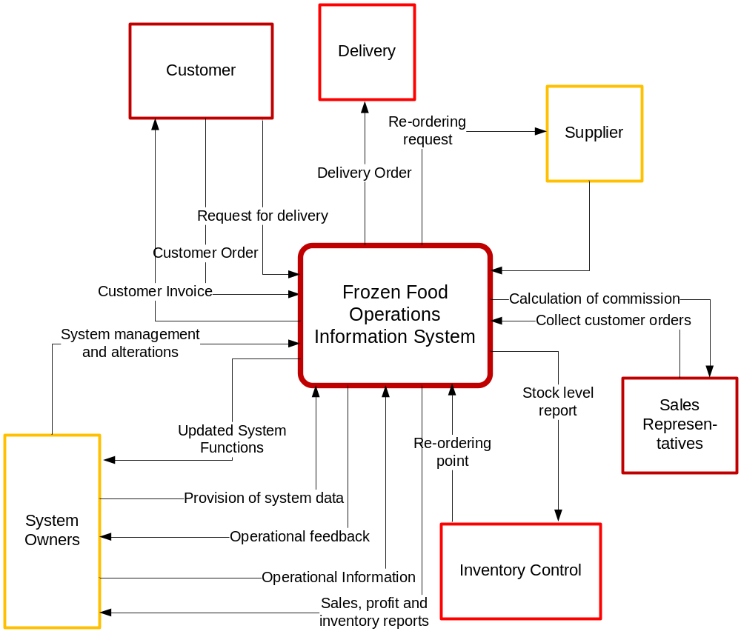
Figure 9 - Context diagram

4.3.3 The use-case diagram (UCD)

The UCD can be useful in different areas. As the design of a system takes shape when being analyzed, new requirements can often be identified and generated. New test cases can be generated and developed as different scenarios surfaces when use cases are designed. Finally, a UCD can serve as a form of communication between system developer and the client.
According to Embarcadero Technologies, Inc. a UCD can be defined as follows: “UCD’s describe what a system does from the viewpoint of an external observer. The emphasis is on what a system does rather than how. UCD’s are closely connected to scenarios. A scenario is an example of what happens when someone interacts with the system.”
Less formally, a UCD can be described according to the following figure.
The use cases (actions/goals)
And the relationships between the above
The actors
The system

Figure 10 - Description of UCD

In order to construct the UCD’s, it was decided that the the system needed to be analysed, dividing all the system components into the four categories above (as indicated in figure 10) to facillitate in the construction process. The first category analysed was the actors category.
The actors
Actors was identified in the system by asking the following questions:
- Through whom are one supposed to know certain aspects in the system? Where was the information obtained?
- Who plays the role of an entity portraying a certain action?
- Who interacts with a certain subject?
An actor can be the initiator of an action, without having to execute that specific action.
By following these steps, the following actors were identified:
- The customer (direct customer).
- Customer (Wholesale customer).
- Customer (SR customer).
- LDPM.
- Deliverer.
- Company owners.
- System owners.
- SR
- Supplier.
- Time .
- IS (delivery subsystem).
- IS (order subsystem).
- IS (inventory subsystem).
- IS (SR payment subsystem).
- IS (Profit and sales calculation subsystem).

Customers were devided into three categories. Direct customers, wholesale customers and SR customers. The distinction was made to indicate the slight diference between them, since they might follow slightly different paths.
A direct customer is a customer that will call the company directly and place an order. This type of client is usually an independent person, who orders small amounts and are unlikely to receive a discount on their purchases. All profits on a sale made to a direct customers, goes directly to the company, without dividing or sharing profits or paying commissions.
A wholesale customer is very similar to a direct customer. They also buy directly from the company, but will buy meals in bulk and receive discount on their purchases.
A SR customer is a customer that places an order through a SR, thus a different flow of activities will occur in order to determine a SR commission and subract the commision from the profit. The SR customer places an order through a SR or refers to a SR with an order and will usually never receive a discount unless their SR has awarded them with one. Here, the SR will receive commision on the sales made, which the company will imburse them with.
When an actor is depicted as “customer”, it symbolises all three types of customers. When only one or two of the customers are included, it will be indicated.
The System
Within the company, numerous different systems exists and some of these individual systems were identified as systems that could be infused with an IS. These different systems are called subsystems. By defining subsystems and integrating them as a whole, could benefit the company in gaining an interrelated correspondent system.
These subsystems include:
- A delivery subsystem.
- Inventory level subsystem.
- SR payment subsystem.
- Order placement subsystem.
- Profit and sales calculation subsystem.
- Wholesale discount subsystem.
- Information management subsystem.

The use cases (actions/goals)
The use cases can be defined as a list of steps, actions, interactions or goals performed between an actor and a system. The use cases was identified by listing all the actions performed or initiated in the company by the different actors in the system.
The use cases included:
Use cases by company owners:
- Provision of a menu to the customers.
- Identification of SR with orders.
- Receive orders from customers.
- Receive orders from SR.
- Provide order detail to IS.
- Send invoice to customer.
- Suggest ideal inventory levels.
- Receive proposed stock orders from LDPM’s.
- Approve proposed stock orders from distribution point managers and place order with suppliers.
Use cases by customers:
- Choose menu items.
- Placement of orders directly to company.
- Receive invoice.
- Indicate delivery rquirements.
- Receive delivery package.
- Cause inventory adjustmenst by ordering.
Use cases by SR customers:
- Choose menu items.
- Place orders at SR.
- Receive invoice.
Use cases by SR:
- Receiving of orders by customers.
- Forward customer orders to company owners.
- Advertising of products.
- Provide menus to customers.
- Receive sales commission.
- Forward delivery requirements to company owners.
Use cases by the entire IS:
- Storage of data and generation of information, including SR information, processing of inventory levels information, processing of order placement information, processing of delivery information and generation of total sales, profit and other reports such as invoices.
- Store order detail.
Use cases by IS (delivery subsystem):
- Receive delivery request.
Use cases by IS (SR payment system):
- Calculation of sales commission totals.
Use cases by IS (ordering system):
- Generation of order data.
- Storage of order information.
Use case by IS (inventory subsystem):
- Adjust inventory levels according to customer orders.
- Generate inventory level report.
System owners:
- Collection and entering of order infotrmation into IS.
- Drawing of SR total sales reports at month end.
- Determination of SR commision percentages based on number of meals sold by SR.
- Entering of commision percentage into IS.
- Pay sales commission.
- Provision and removal of data in the IS.
- Management of system information.
- Management of IS.
- Maintain IS.
- Use IS as prototype in future.
- Application of system adjustements.
- Receive advice from external system architect when unresolvable IS issues occur.
- Study reports and information generated by IS.
Use cases by LDPM:
- Draw and study inventory reports.
- Compare inventory with suggested inventory levels.
- Propose a stock order for local distribution point to company owners.
- Draw invoice and picking slip.
- Pick and package orders.
- Receive orders from suppliers.
- Re-stock freezers.
- Conduct regular stock counts.
- Notify company owners of neccesary inventory level adjustments caused by damage or expiration.
Deliverer:
- Pick up packaged order.
- Deliver packaged order.
Time:
- Adjust inventory levels according to losses due to expiry and damages.
External systems architect:
- Provide IS advice.
Supplier:
- Receive orders from company owners.
- Deliver orders to local distribution points.

And the relationships between the actors, the system and the use cases.
The relationships was determined by analysing the different actors, their Use cases (UCD’s),other actors involved in the use case and the different subsystems. The relationships was determined between the different elements and drawn within the appropriate subsystems. The use cases can be seen below in Figure: 11, 12, 13, 14 and 15.

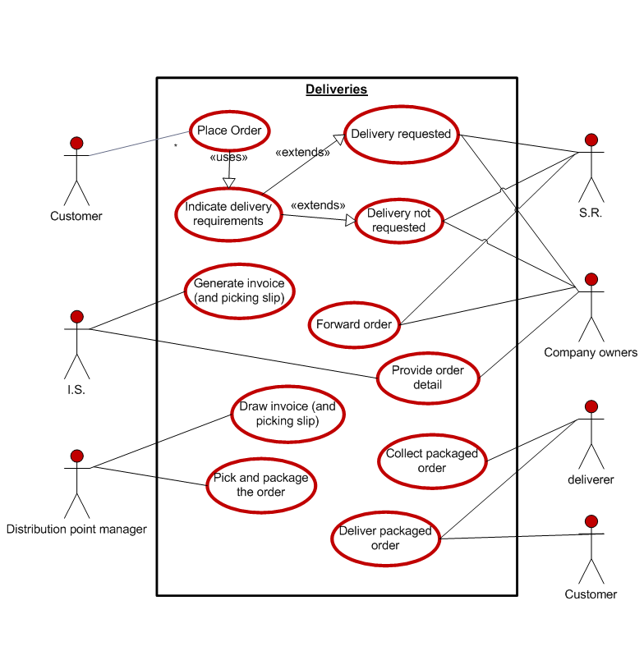
Figure 11 - Deliveries subsystem UCD.

Distribution point managers, current and future, will have access to invoices that have been generated by the system for clients that will receive meals, which will be packaged at their specific distribution point. The invoices generated by the system are printed and used by the distribution point managers as picking slips to pick and package the meals that have been ordered by the customer. These invoices are placed in the finished delivery package and delivered to the client with the package.

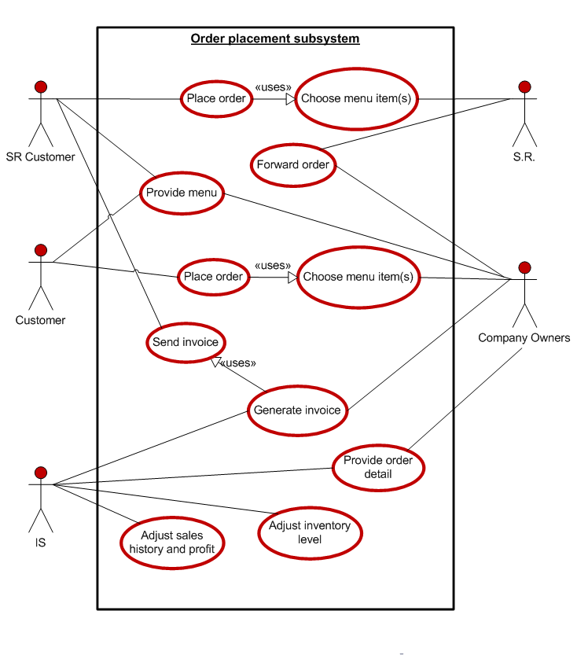
Figure 12 - Order placement subsystem UCD.
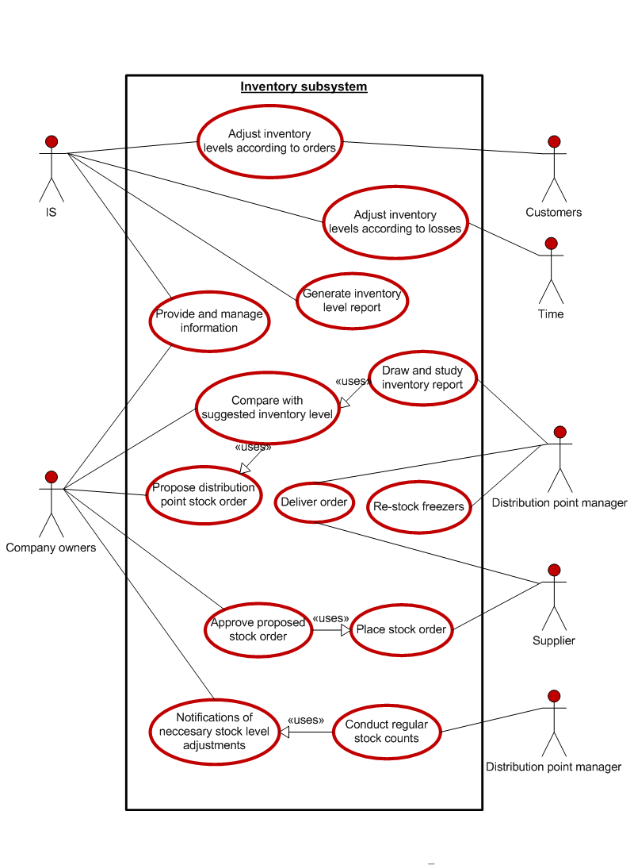
Figure 13 - Inventory subsystem UCD.

In the delivery subsystem, the LDPM has access to draw customer invoices which they should be able to print out and use as order picking slips. Likewise, when the inventory levels alter, the LDPM should also be able to access and view the inventory level reports. This is noticeable from the diagram above. This report levels can be used to verify that the stock in the freezers corresponds to the stock that is supposed to be in the system. When losses have been incurred, it can easily be determined via this method. The report is also useful for customer inquiries. With this system, it is possible to determine immediately whether or not enough stock is on hand to meet a customer’s order, when the customer inquires about it.

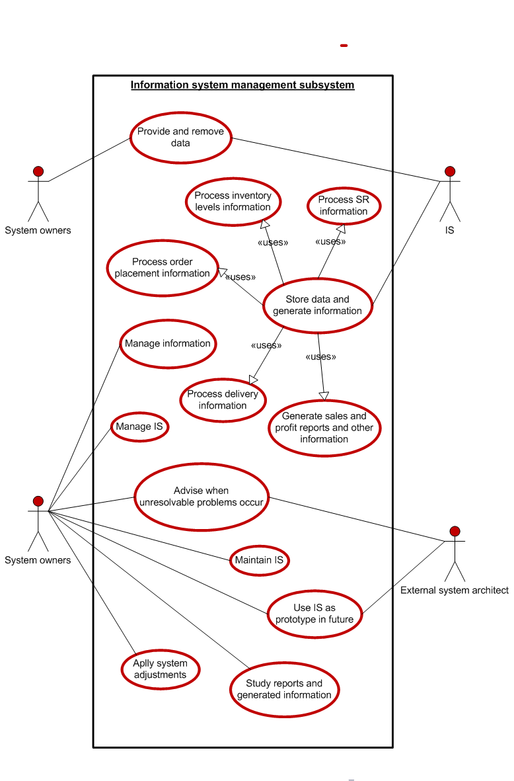Figure 14 - IS management subsystem UCD.

When the above UCD is investigated, it will be noted that, included in the system owner Use cases, is the application of system adjustments, maintenance of the IS as well as the management of the IS. The subsystem has been approved by management, since management has the basic relevant knowledge to operate the MS Access software and prefers understanding and managing the system themselves. In case irresolvable issues occur, management will seek advice from an external system architect. The MS Access database can also serve as a prototype for a future web based IS when the company expands, requires a more complex system and has the means to pay for the operation.
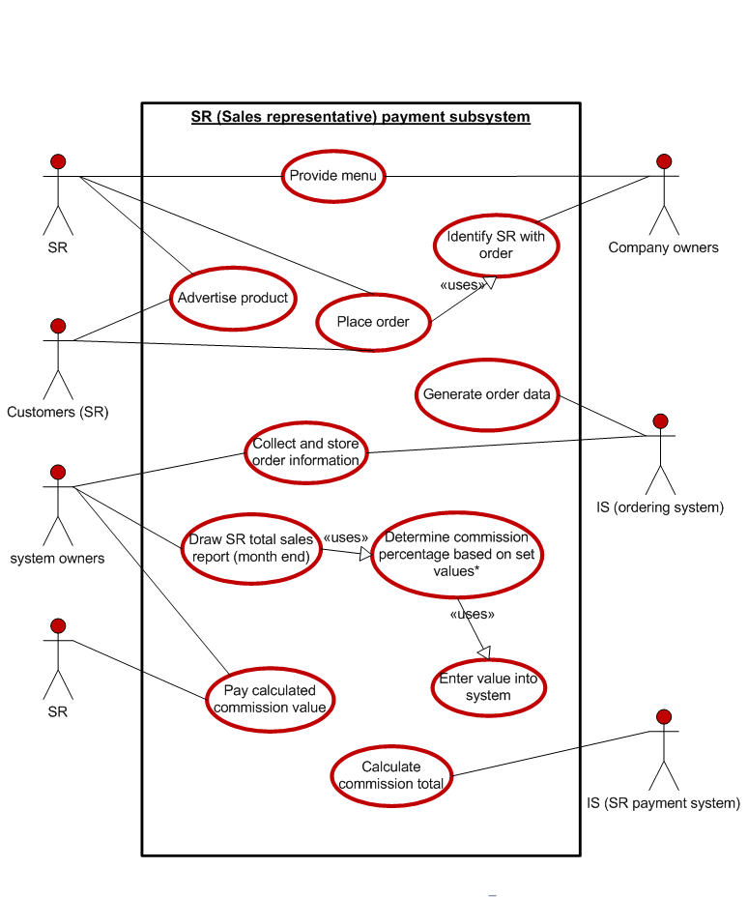
Figure 15 - SR payment subsystem UCD.

System owners determine commission percentages based on set values. These set values is predetermined by management and the percentage scale values are based on the number of meals sold during a month. The more meals are sold, the higher the SR commission will be. By using the IS and drawing a report, the number of meals sold by a SR during a month, can be seen. With these numbers, management will be able to determine the percentage of total sales commission that will be awarded to the SR and enters this percentage into the IS. The system then calculates the amount payable to the SR.
Because of the relatively small size of the company, the company owners do the majority of the work. According to definition, the company owners can be regarded as the system owners as well. “A system owner is an individual with managerial, operational, technical, and often budgetary responsibility for all aspects of an IT system (NIST, 2006).” Just the same, the company owners are two individuals who are currently in charge of these different aspects. The reasons for the distinction made between the different actors is because the duties of company management might change as the business grows and certain duties moved onto employees as the owners will place more focus on other work. System owners’ work will always include the mentioned aspects involving the responsibility of the IT system.

4.3.4 Use case narratives

The use case narratives are used, to describe in more detail, the structure of a UCD, by providing more elements than a simple sequence of system to user interactions. The definition for the UCD can be divided into three main parts, which includes the following as indicated in figure 16.

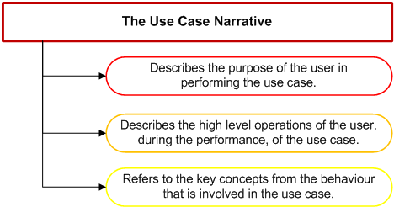
Figure 16 - UC narrative features

Some of the structures of the UCD’s were described in more detail using the Use case narratives. The Use case narrative breaks down specific Use cases in more elements as can be seen below in table: 3, 4 and 5. In each of the following narratives, the Use case (action, goal or performance) name is indicated in the first row and the UCD being investigated is indicated at the Use case I.D.
Use case name: | Adjust inventory levels according to losses
Use case type: | Business requirement.
Use case: | Inventory subsystem.
Priority: | High.
Source: | Time.
Basic description: | The use case describes the event of time being a factor in the adjustment of inventory levels. With time, meals can damage or expire and the company will not be able to sell those specific meals. The meals will be removed and necessary inventory level adjustments need to be made on the system.
Related use case: | Adjusting profit levels according to losses.
Participating actors: | IS.
Other interested stakeholders: | LDPM’s
Pre-conditions: | Menu items need to be in stock, before time, or rather the damaging and expiring of items can occur.
Post-conditions: | Inventory levels need to be adjusted.
Flow of events: | Actor action: | System response:
 | Step 1: Time passes and meals expires. | Step 2: LDPM identifies expired and damaged meals and notifies company owners.  Step 3: Company owners will subtract the number of damaged and expired meals from the system.  Step 4: The IS will display the inventory level.
Table 3 - Adjust inventory levels according to losses Narrative

Use case name: | Identify SR with order
Use case type: | Business requirement.
Use case: | SR payment subsystem.
Priority: | High.
Source: | SR.
Basic description: | The use case describes the event where the customer has placed an order with a SR. The company owner needs to identify if the product was sold due to the work of a SR or not. Customers can either place an order with a SR, or phone the company directly and recognise their sales agent with the order. Only through this can the SR receive their commission, if not, all the profit will go to the company.
Participating actors: | Company owners and customers.
Other interested stakeholders: | IS.
Pre-conditions: | An order needs to be placed and a sale made before commission on a sale can be paid by the company to the SR.
Post-conditions: | Commission will be paid to the SR at the end of each month.
Flow of events: | Actor action: | System response:
 | Step 1: Customer places an with the SR. | Step 2: The SR forwards the order to the company owners.  Step 3: Company owners identifies the SR with the order.
Alternative flow of events: | Step 1: Customer places an order directly to the company owners after a SR advertised the product to the customer. | Step 2: Customer indicates a SR with the order.  Step 3: Company owners identifies the SR with the order.
Table 4 - Identify SR with order narrative

Use case name: | Propose distribution point stock order.
Use case type: | Business requirement.
Use case: | Inventory subsystem.
Priority: | High.
Source: | Distribution point manager.
Basic description: | The LDPM draws a report from the system and compares it to a set list of supposed inventory levels, pre-determined by management. They then propose a stock order to management, based on the differences in the values.
Participating actors: | Company owners.
Pre-conditions: | Movement of inventory needs to occur.
Post-conditions: | Stock orders can be made and ideal inventory levels can be kept.
Flow of events: | Actor action: | System response:
 | Step 1: Draw and study inventory report. | Step 2: Compare values with suggested pre-determined stock values.
 |  | Step 3: Determine difference in values
 |  | Step 4: Propose stock order to management.
 |  | Step 5: Management approves or disapproves.
Table 5 - Propose distribution point stock order narrative.

According to the inventory subsystem UCD, the distribution point manager will always have to draw reports and compare the inventory level reports with the pre-determined preferential inventory level in order to determine whether or not inventory needs to be ordered. This is not always necessary since this is a function already built into the IS. The company owners can determine from the system the amount of inventory that needs to be ordered. There are two explanations beyond the reasoning in drawing the UCD the way it has been depicted. As discussed earlier, as the company grows the company owners’ responsibilities need to be shifted downwards in the structure, as their focus will be shifted to other important activities. LDPM’s will receive the duty of ensuring correct inventory levels. They will also have to approve their own stock orders and take responsibility for the decisions they make regarding their orders. Secondly, it ensures a double parallel control system. The LDPM’s will be able to verify the physical flow of items with the flow of information on the system. This is ideal since deviations on the inventory levels will be determined early, thus making the investigation on the deviation easier.

4.4 The Entity Relationship Diagram

This diagram can be assumed to be the most important diagram for the analysis of this project and for the design of the database. In relational databases, all the required data is collected and divided into selected tables. This is to ensure that the data is stored in an organised manner, which will make it easier to track through records in the database. This eliminates the problems often encountered when all the information is written in a single line or record, or when all information is saved in a certain sheet, for example an Excel spreadsheet.
After all the tables with their different information categories within the tables have been designed and populated within the tables, the tables are linked via relationships. The relationships are established by a decided table primary key, which is present in the specific table, as well as present in another table, as a foreign key. The relationship between two tables is illustrated by a line joining two or more of these tables. At the end of a joining line, the manner in which the two tables have been joined is also indicated. This is visible in the diagram below and these manners include, one-to-one -, one-to-many - and many to many relationships.
This form of data modelling was used to set the system requirements for the database that were determined throughout the project. The ERD assisted the project team with the design of the IS and was used as a plan throughout the construction thereof. It served as a map which could be followed and was often referred to. Figure 17 represents the frozen food company system’s data requirements.
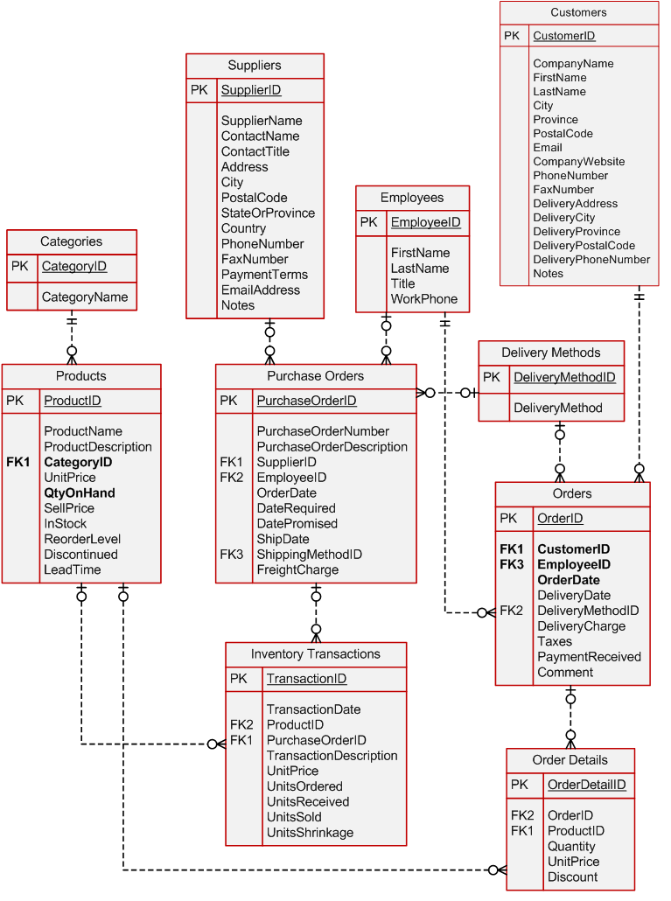
Figure 17 – ERD

5. System design
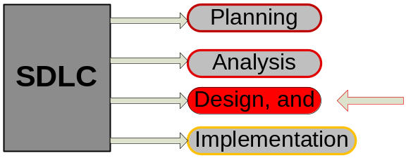
Figure 188 - Figure indicating the design phase of the SDLC.

The next phase of the SDLC, where the focus will be shifted, is the design phase. In system design, detailed descriptions are used to describe the different design functions and options. The majority of the detail and design function descriptions were captured during the development phase. Business rules, process diagrams and other documentation were also included. Those were used for the design of the IS. During the design phase, the identified requirements were used as inputs for the design of the IS. A set of one or more design elements was included in the IS, for each requirement. These design elements represents the desired software features. The ERD diagram constructed in the system analysis was very useful in determining the data related to the different design elements. This assisted the project team in developing the IS.

5.1 System design introduction

As mentioned in Section 3, Microsoft Access was the program chosen for the frozen food company database. This database will be used as a powerful tool in establishing the business. The software can also be used as a prototype for the design of a web based IS in the future. Until then the use of the Microsoft Access database will support the company in collecting and storing data and simplifying and even automating certain processes. Data will be used to generate useful information and assist company owners with the useful information that will help them gain knowledge and to make important business decisions.

The database allows DeliciouSavings to collect information regarding the following elements:

- Customers
- Inventory Transactions
- Suppliers
- Employees
- Categories
- Products
- Purchase Orders
- Delivery Methods
- Orders, and
- Order Details

The IS was designed to be user-friendly, making use of logical layouts. Lists where records are shown were refined using queries so that only necessary information is displayed where required. Reports were designed to display essential information and forms were designed to enable the user to navigate between reports without effort. These reports include the following reports:

- Customer Listing
- Inventory Level
- Invoice
- Orders summary
- Product Cost Comparisons
- Product Purchases by Supplier
- Product Transaction detail
- Purchase Orders
- SR Sales Details, and
- Total Sales, Cost & Gross Profit By Customers

5.2 Design Limitations and Constraints

During the design phase of the IS, certain design limitations and constraints were experienced by the project team and it included the following:

- Time was a constraint, since certain design features could still be refined, especially visual design features associated with the overall look of the system. Also due to the relatively poor knowledge of MS, the project team was limited to design a refined system.
- In certain cases, MS Access was limiting to the project team since some of the designs could not be changed into more desirable layouts.

To conclude, the User Manual in Appendix: A contains more detail regarding the physical design and the functionality of the IS. The accompanying disk, at the back of the booklet, contains the IS which can be viewed to obtain a better experience of the operation of the system.

6. Conclusion

The aim of the project was to clearly identify problems that the company is experiencing, research possible solutions and choose and implement the best alternative with the use of engineering strategies.
Problems that were experienced by the company were discussed, in the first section of this document and a root cause was identified. Possible solutions to solve the problems were discussed in the Literature Study and it was decided that an IS be developed and designed for DeliciouSavings.
Industrial Engineering tools, methods and techniques were used in the development phase of the project. It included the drawing of logical model diagrams. This provided the project team with an understanding of the functionality of the business and guided them in the system design phase.
During the system design phase, a Microsoft Access IS was constructed. The system satisfies the needs of the company by solving the problems discussed in the problem definition. With the implementation of the system, efficient and effective growth of the company can be secured, helping the company gain a competitive advantage in the market.

7. References

Bentley, L.D. and Whitten, J.L. (2007). System Analysis and Design for the Global Enterprise. 7th ed. McGraw-Hill Irwin, New York.

Chapple, M. (2012). Entity-Relationship Diagram. Available: http://databases.about.com/cs/specificproducts/g/er.htm. Last accessed 27th April 2012.

Copeland, L. (2009). Use Cases and Testing. Available: http://www.stickyminds.com/sitewide.asp?Function=edetail&ObjectType=ART&ObjectId=3428. Last accessed 27th

Cox, H. (2003). New Product Development and Product Supply within a Network Setting. Industry and Innovation. 10 (3), 197-217.

Daskin, S. (2002). An Inventory-Location Model: Solution algorithm and Computational Results. Annals of Operations Research. 110 (1), 83-106.

Datamonitor Plc. (2004). Birds Eye Case Study. Revitalizing the Image of Frozen Foods. 1 (1), p9, 12,.

Datamonitor Plc. (2008). Case StudyFrozen Food Industry Profile Italy..Frozen Food Industry Profile Italy.. 1 (1), p2, 30.

Dominigue, J. (1988). Extracting topographic Structure from Digital Elevation Data for Geographic Information System Analysis. Photogrammetric Engineering and Remote Sensing. 54 (11), 1593-1600.

Donahue,L. (2009). Definition of Data flow Diagrams. Available: http://www.ehow.com/about_5095247_definition-data-flow-diagrams.html. Last accessed 28th April 2012.

Georgiadis,P. (2005). A system dynamics modelling framework for the strategic supply chain management of food chains. Journal of Food Engineering. 70 (2), 351-364.

Hall, J. (2012). Birds Eye boss Martin Glenn: 'frozen food is the future'. Available: http://www.telegraph.co.uk/finance/newsbysector/retailandconsumer/7869883/Birds-Eye-boss-Martin-Glenn-frozen-food-is-the-future.html. Last accessed 30th April.

House, C. (2009). Amy's Kitchen Case Study. From Start-Up to Leading Natural & Organic Frozen Food Brand. 1 (1), 1.

Joles, J and Charbonneau, S. (1988). United States Military Academy West Point, New York 10996. An Enlistment Bonus Distribution Model. 1 (1), 4.

Kruggel, C. (2000). Oracle definition. Available: http://searchoracle.techtarget.com/definition/Oracle. Last accessed

Learmonth, P. (1984). The information system as a competitive weapon . Communications of the ACM. 27 (12), 1193-1201.

Locke, J. (2008). Information Technology in Business: The big picture. Available: http://www.freelock.com/information-technology-business-big-picture. Last accessed 28th April 2012.

Microsoft. (2012). What is Access?. Available: http://office.microsoft.com/en-us/access/what-is-microsoft-access-database-software-and-applications-FX102473444.aspx. Last accessed

Mills,K. (2011). Information Systems Used in Modern Business. Available: http://www.itcollaborate.com/71/information-systems-used-in-modern-business/. Last accessed 28th April 2012.

NIST, "Creating a Patch and Vulnerability Management Program," NIST Special Publication 800-40, Ver. 2 (Jan. 2006) (full-text).

Patil, G.P.. (2002). Weighted distributions. Encyclopedia of Environmetrics. 4 (1), 2.
PC.net. (). MySQL. Available: http://pc.net/glossary/definition/mysql. Last accessed 1st May 2012.

Rodrigue, J. (1998). THE GEOGRAPHY OF TRANSPORT SYSTEMS. Linear Programming. 2 (4), 1.

Stumpf and Teague, Object-Oriented Systems Analysis and Design with UML, as modified by W.L.Honig for Comp 320, Loyola University Chicago, Spring 2008.

Umble,E. (2003). Enterprise resource planning: Implementation procedures and critical success factors. European Journal of Operational Research. 143 (4), 241-257.

Appendix A: User Manual

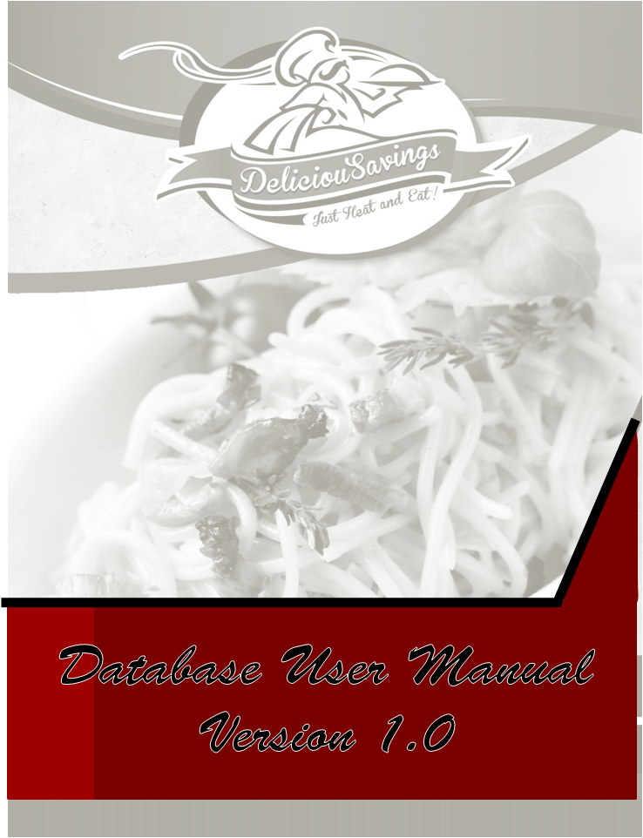

Table of Contents

1. Introduction 4
2. New Orders 4
2.1 The Customers Field 4
2.2 The Employees Field 4
2.3 The Delivery Method Field 4
2.4 The comments Field 4
2.5 The Order ID Field 4
2.6 The Order Date Field 4
2.7 The delivery Date Field 4
2.8 The Payment Received Field. 4
2.9 The Order Sub Total Field. 4
2.10 The Order total field. 4
2.11 Orders Summary Button 4
2.12 Other Buttons on the Orders Form 4
3. Add New Customers 4
3.1 Customer Tab 4
3.2 Order Detail Summary Tab 4
4. Inventory Management 4
4.1 Product ID 4
4.2 Product Name and Category Field. 4
4.3 Lead Time and Reorder Level Fields 4
4.4 Units on Hand and Units on Order Field 4
4.5 Inventory Transactions Tab 4
4.6 The Product Notes Tab 4
4.7 Create New Purchase Order Button 4
4.7.1 The Supplier Field 4
4.7.2 The Description Field 4
4.7.3 The Pick-up Date and Date Required and –Promised Field 4
4.7.4 The Products Ordered Label 4
4.8 Browse Purchase Orders Button 4
4.9 Add or Delete Employees Button 4
4.10 Add or Delete Suppliers Button 4
4.11 Add or Delete Product Categories Button 4
4.12 Add or Delete Shipping Methods: 4
4.13 Change Our Company Information Button 4
5.1 Open Report Button. 4
5.2 The Edit Report List Button 4
5.3 Inventory Level Report 4
5.4 Invoice Report 4
5.5 Product Cost Comparison Report 4
5.6.1 Product Purchases by Supplier Form 4
5.6.2 Product Purchases by Supplier Report 4
5.7 Product Transaction Detail Report 4
5.8 SR Sales Details Report 4

Table of Figures

Figure 1- Example of an arrow and the numbering. 4
Figure 2 - Introduction Page 4
Figure 3 - Security Alert 4
Figure 4 - New Orders Form 4
Figure 5 - Customer Listings Report 4
Figure 6 - Employees Form 4
Figure 7 - Add or Delete Delivery Methods Form 4
Figure 8 - Calendar Image 4
Figure 9 - Orders Summary Report 4
Figure 10 - Add or Delete Customer Form 4
Figure 11 - Order Detail Summary Tab 4
Figure 12 -Products Form 4
Figure 13 - Categories Form 4
Figure 14 - Product Notes Tab 4
Figure 15 - Purchase Order Form 4
Figure 16 - Suppliers Form 4
Figure 17 - Browsing Purchase Orders 4
Figure 18 - My Company Information Form 4
Figure 19 - View Reports Form 4
Figure 20 - Reports Form 4
Figure 21 - Inventory Level Report 4
Figure 22 - Invoice Report 4
Figure 23 - Product Cost Comparisons Report 4
Figure 24 - Product Purchases by Supplier Form 4
Figure 25 - Product Purchases by Supplier Report 4
Figure 26 - Product Transaction Detail Report 4
Figure 27 - SR Sales Details Report 4
Figure 28 - Gross Profit by Customers Report 4

1. Introduction

The following user manual will serve as a guide on how to use the IS developed for DeliciouSavings. With the guide, the fundamental functioning of the system is also conveyed to the user and the limitations and constraints for the different sections are mentioned. Screen shots will be used throughout the document to explain the system functions and certain discussions on the specific screen shots will be made and indicated with a red arrow and a number where necessary. The arrow is shown in Figure: 1. All the text describing or mentioning the name of a button, label, table, query, form or report will be italicised.
A: 1
Figure 19- Example of an arrow and the numbering.
This is the fist view the user will have when the programme is opened. Before the programme can be used, it is important to note that MS Access will always ask the user to activate the content of the database before the user will be able to use the programme. MS Access disables the content for security reasons. See the security warning at A: 1 below.
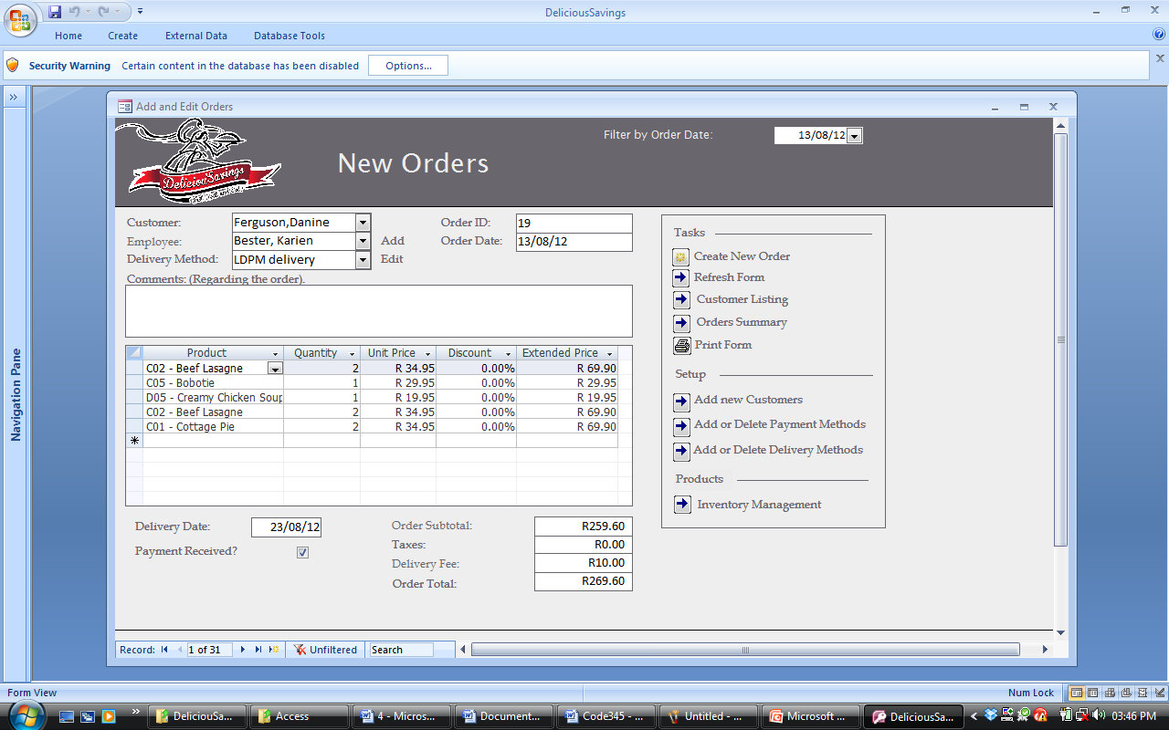Figure 20 - Introduction Page
A: 1

The user should click the options button next to the security warning and select the Enable Content button shown below and then click ok.
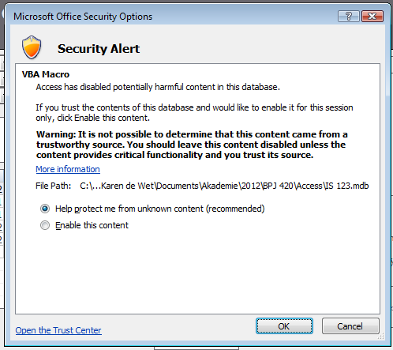
Figure 21 - Security Alert

2. New Orders

After the content has been enabled, the programme is ready for use. The New Orders form is probably the most important form in the database and users will be able to use this form to record new customer orders and to help the user navigate through numerous other forms and reports. The New Orders form can conveniently be used while a customer is on the phone giving an order ,or via other methods. For the instructions given in Section: 2, please refer to Figure: 4.

2.1 The Customers Field

Before any new order can be recorded, the user has to click on the Create New Order button. This button is situated below the Tasks label. This process saves the previous record and enables the user to enter a new record instead of editing the record currently open. If the user finds it simpler, he/she can use the new record button, indicated with a star, at the bottom of the form. See A:2 in Figure: 4 below.
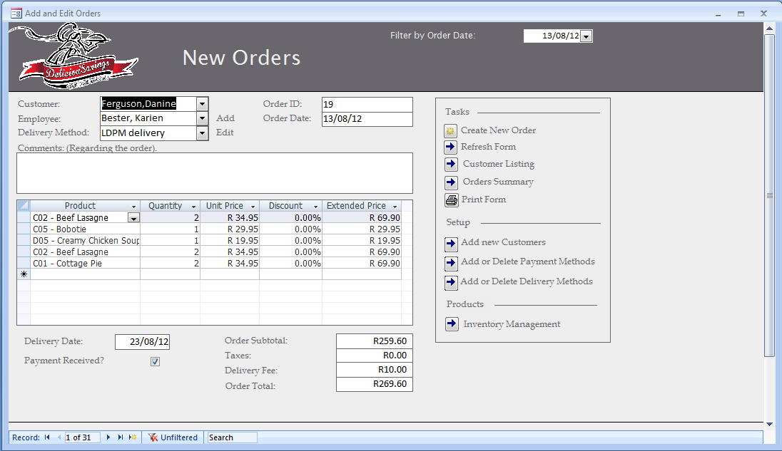
A: 2
A: 3
Figure 22 - New Orders Form

When a new order needs to be created and it is an existing customer making the order, the customer name and surname can be selected from the drop down menu next to the customer label. If it is a new customer, the customer can be added by clicking on the arrow button on the left of the Add new customers label in the Setup menu. This will be discussed in Section: 3 of this document. If a new order needs to be recorded and the user is not sure whether or not the customer has made an order before or not, the user can use the search option at the bottom of the form. See A: 3 in Figure: 4. The customer name or surname can simply be entered and the customer name and surname wil appear in the drop down list next to the Customer label, if it is an existing customer of the company. An easier way of doing this is available. When clicking the Customer Listing button, which is situated below the Tasks label, a form will appear showing all the customers and their information as indicated in Figure: 5.

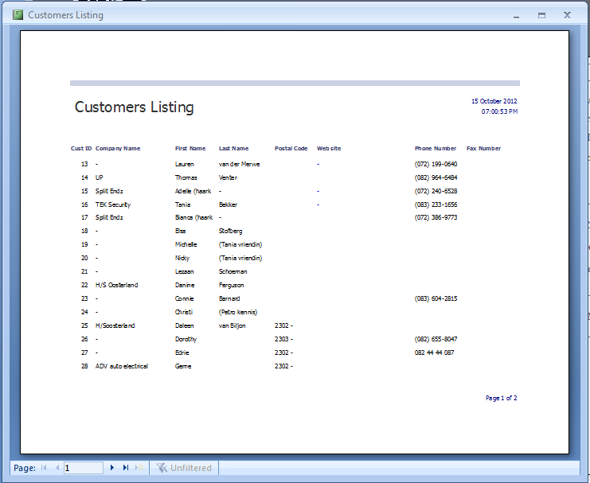
A: 4
Figure 23 - Customer Listings Report

Please note that at the bottom of each form, there will be buttons available to skip and navigate between records. These buttons are indicated at A: 4 in Figure: 5.

2.2 The Employees Field

Next to the Employee label in the New Orders Form, the employee or the SR that assisted the customer in the sale should be selected from the drop down list. If the employee name is not one of the options in the drop down list, a new employee can be added by clicking on the Add button next to the Employee drop down list. When the Add button is clicked, a form will appear looking similar to the form in Figure: 6 below.
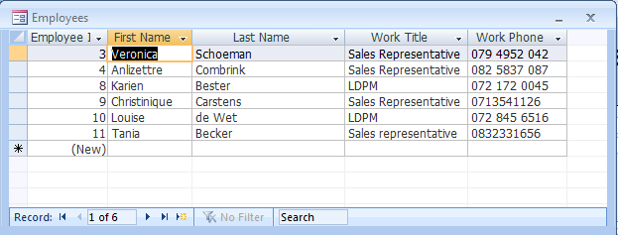Figure 24 - Employees Form

The new employeee information need to be typed in at the first available row and the associated column. An employee can be deleted by erasing the information in the specific row.
The reason why an employee needs to be added is to be able to determine the exact number of meals each SR sold and his/her total sales for the month. Thus, this will be a required field in the form.

2.3 The Delivery Method Field

Below the Employees drop down list and next to the Delivery Method label, is a drop down list where the delivery method should also be specified. If the delivery method is not one of the options specified in the list, it can be added by clicking the Add or Delete Delivery Methods button underneath the Setup label. The following form shown in Figure: 7 will appear.
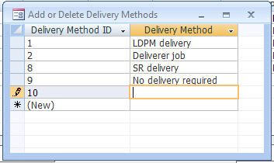
Figure 25 - Add or Delete Delivery Methods Form

The user should type the name of the new delivery method underneath the Delivery Method column and exit the form. In order for the new delivery method to be displayed in the delivery method drop down list, the form needs to be refreshed. The form can be refreshed by clicking the Refresh Form button below the Tasks label.

2.4 The comments Field

Just below the Delivery Method label is a Comments label. Any comments regarding the order can be typed in the space provided below the label and this information will be stored and visible on the invoice that will be discussed later in this document.

2.5 The Order ID Field

The number next to the Order ID label is a label that the system will generate automatically and this will also be the number used as an invoice number on the invoice which will be discussed later in this document. The user does not need to fill in a number in the Order ID field.

2.6 The Order Date Field

The order date should be filled in by the user in the same format as the one provided. This is a required field and is important since the date of the order is one of the variables used to calculate sales commission.

2.7 The delivery Date Field

The user needs to type the date, when the company will deliver the customer order, in the Delivery Date field. When clicking on the Delivery Date field, a calendar will be visible as indicated in Figure: 8. The user can click on this calendar icon in order for the system to provide a calendar, which the user can use to select the appropriate date. The user does not have to use this calendar and can also enter the date in the format provided.
Figure 26 - Calendar Image

2.8 The Payment Received Field.

Next to the Payment Received label, a checkbox is visible. When a customer payment is received, this checkbox can be checked in order to keep control of the outstanding payments. The check box can be left unchecked and checked at a later stage when the customer payment was received.

2.9 The Order Sub Total Field.

The most important aspect of the New Orders form is the orders itself. In order to get an order total, the order needs to be typed into the form. To do this, the user should do the following:
- Click on the drop down list below the Product column and select the product.
- Click in the same row underneath the Quantity column and enter the quantity ordered from the specific product.
- If any discount is given to the customer, enter the discount in the Discount column.
- Do this for every product ordered.
After the product is selected from the drop down list, the unit price will automatically appear in the Unit Price column. After the quantity has been entered in the Quantity column, the extended price will also automatically appear in the Extended Price column.
The discount function can be used to give a discount on specific items only, by only specifying the discount for a specific item in the item row, or the discount can be given on the total order by entering the discount next to each item. The discount will automatically be subtracted from the order amount and the order sub total calculated.

2.10 The Order total field.

The delivery fee and taxes can be entered by the user in the fields next to the Delivery Fee and Taxes labels. This will be added to the order sub total amount and provide the user with the order total next to the Order Total label.

2.11 Orders Summary Button

The Orders Summary button on the New Orders form can be selected if the user would like to see a quick preview of the entire collection of orders, grouped by the customer. This form is ideal when the user would like to view the customers order information including sales, their SR’s, order date(s) and more.
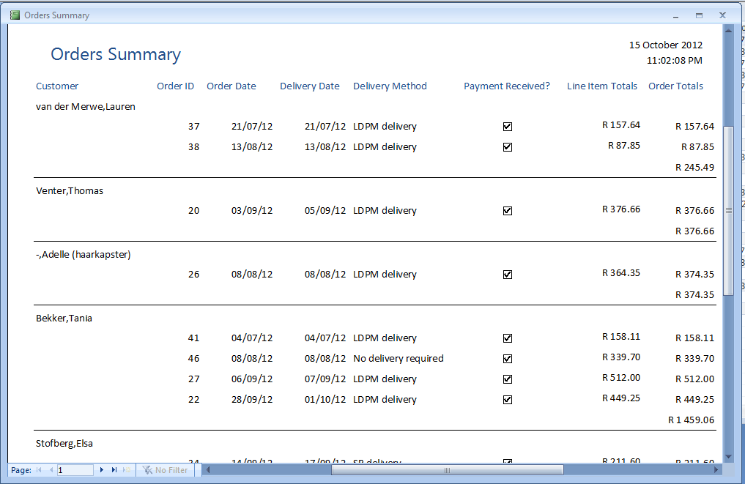Figure 27 - Orders Summary Report

2.12 Add New Customers

The Add New Customers button that is visible on the New Orders form redirects the user to a form where all the customer details, including their delivery details can be added. After the button has been clicked, the form shown in Figure: 10, appears.
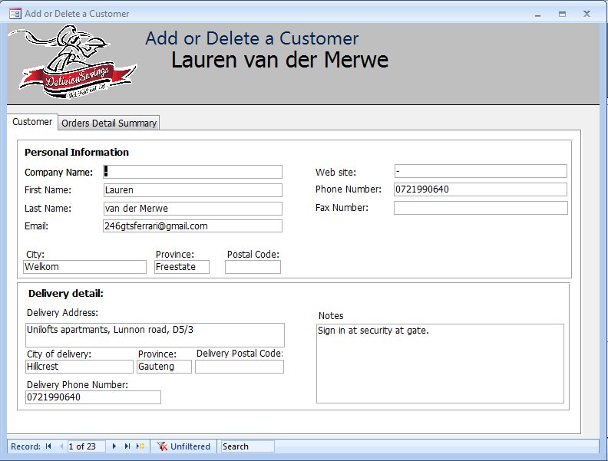Figure 28 - Add or Delete Customer Form

The name of the form is Add or Delete Customer form. Two tabs are available for selection by the user. These tabs are the Customer tab and the Order Summary tab.

2.12.1 Customer Tab

The first tab to be discussed is the Customer tab. As discussed in Section: 2.1 A: 4, the navigation panes can be used to navigate between the different customer records. As the user navigates through the different records, the customer names associated with the record will be displayed on the top ribbon of the form below the form name.
The form is divided into two blocks. The first block, under the Personal Information label holds the fields associated with the customer’s personal information. The fields are not required, but it is advised that as many information are collected, about the customer, as possible. The more information the user has, the more he/she can do with it.
The next block on the form is labelled Delivery Detail. The delivery detail is all the information associated with the delivery of the meals. This might not be required since all the customers will not make use of the delivery system. The field in the Delivery Details block labelled Notes can be useful to note information relative to the delivery, for example, that the customer does not have a door bell or that the delivery should not be made at the front door et cetera.
When a new customer needs to be added, the New Record button (as discussed in Section: 2.1 A: 2) at the bottom of the form, needs to be clicked. A new blank form will appear where the customer detail can be entered. When the user is finished, he/she can simply exit the form and return to the New Order form. The customer name and surname will now be available on the Customer drop down list, after the form has been refreshed with the Refresh button.

2.12.2 Order Detail Summary Tab

The Order Detail Summary tab is the second tab available on the Add or Delete Customer form. When the tab is selected, the form visible in Figure: 11 will open.
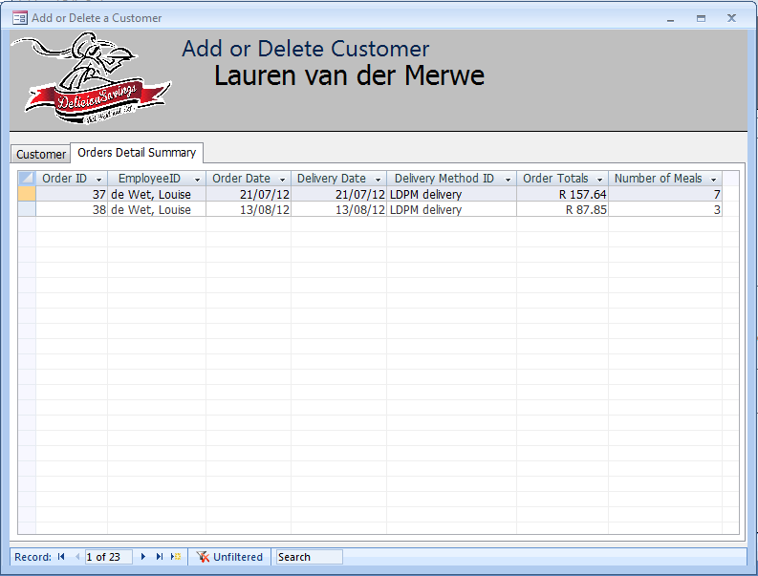Figure 29 - Order Detail Summary Tab

The information displayed in this form, depends on the customer selected in the Customer tab. In this example, the customer Lauren van der Merwe was selected and the form will display the orders that she has made and all the information related to her orders, as shown in the figure above.

2.13 Other Buttons on the Orders Form

Buttons also visible on this form is the Inventory Management form that will be discussed in Section: 3 and the Print Form button that can be used to print the New Order form.

3. Inventory Management

The last button to be discussed on the New Orders form is the Inventory Management button below the Products label. When the button is clicked, the following form in Figure: 12 will appear on the user’s screen.
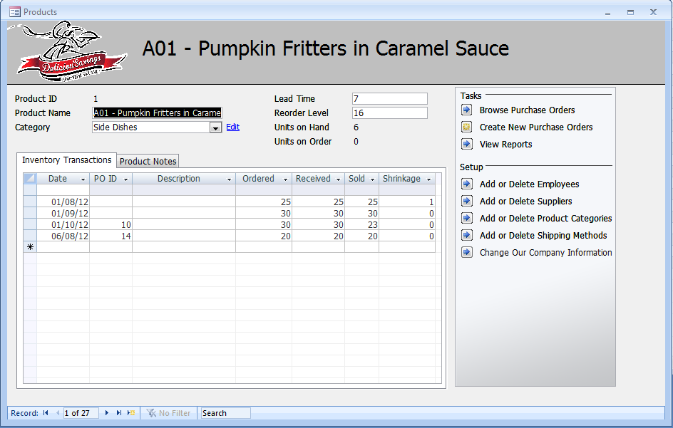Figure 30 -Products Form

The form in Figure: 12 is called the Products form and can also be considered as one of the most important forms in the IS, since it deals with everything regarding the products, the ordering thereof, the inventory levels, the suppliers of the food, the purchases and more. Some of the buttons of this form has already been discussed in Section: 2. These buttons include the navigation buttons and the new record button at the bottom of the form. The rest of the fields and buttons of this form will be discussed throughout the rest of Section: 3.

3.1 Product ID

The product ID field next to the product ID label is the number that will automatically be generated by the system and recognises the item selected. This number can not be changed by the user. In the example given above, the product ID is given as 1, and this number associates with product A01 – Pumpkin fritters in Caramel Sauce, which will be displayed at the top of the form. As the user navigates through the different products, the different names will be displayed at the top of the form.

3.2 Product Name and Category Field.

Next to the Product Name label, is the Name and the product code of the product that will automatically be displayed as the user navigates through the different records. This also applies for the Categories field next to the Categories label, which indicates the category of the meal. If new meals and new meal categories are added to the product menu, and the meal category is not available on the drop down list next to the Category label, the user can add it by clicking on the Add or Delete Product Categories button below the Setup label on the form. After the user has clicked the Add or Delete Product Categories button, the form in Figure: 13 will open. The user can simply enter the new category name in the first available row below the Category Name column and exit the form. The new category will now be added to the drop down list is in the form.
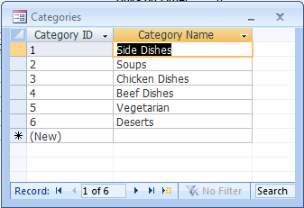
Figure 31 - Categories Form

3.3 Lead Time and Re-order Level Fields

The field next to the Lead Time label automatically displays the lead time for production of the meals and varies from product to product. The same applies to the Re-order Level that will also be displayed automatically and varies. The re-order level indicates the level of meals that need to be in stock. In the example in Figure: 11 it is visible that a new order needed to be placed already, since the units on hand level is much lower than the re-order level.

3.4 Units on Hand and Units on Order Field

The Units on Hand field next to the Units on Hand label displays the number of units on hand, or the number of meals the company has as inventory. The Units on Order field next to the Units on Order label displays the number of meals that was ordered by the company, but still needs to be received.

3.5 Inventory Transactions Tab

On the Products form, two tabs are visible namely the Inventory Transactions Tab and the Product Notes Tab. The Inventory Transactions Tab displays all the inventory transactions relevant to the specific product. With this tab, the user is able to see the following:
- The date the purchase order was made, below the Date column.
- The purchase order ID below the PO ID column. The purchase order ID is also the number on the invoice that the supplier provides the company with.
- The description of the purchase order, if any, can be found in the Description column.
- The number of meals that was ordered can be found in the Ordered column.
- The number of meals received by the supplier can be seen in the Received column.
- The number of meals sold from that specific purchase order can be seen in the Sold column.
- The values found in the Shrinkage column, displays the number of meals of the specific batch, which needed to be disposed of, because of damage or expiry.
As the user navigates between the different product records, he/she is able to see this information associated with the different products.

3.6 The Product Notes Tab

The Product Notes Tab displays the description of each meal. This information can be edited or altered as the recipes may change with time. The user is welcome to insert the meal recipe or any other information regarding the meal in the Product Notes field, below the Product Notes tab label. When the Product Notes tab is selected, a similar view to the one in Figure: 14 will be visible to the user.
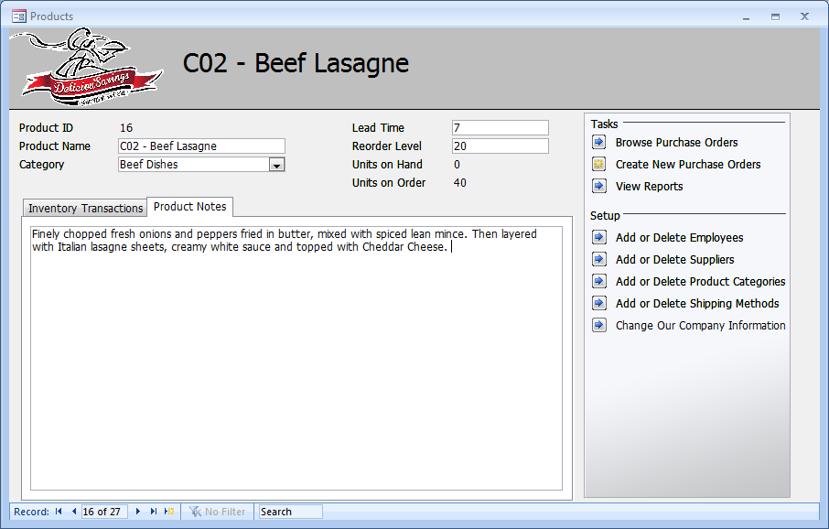Figure 32 - Product Notes Tab

3.7 Create New Purchase Order Button

All the information displayed on the Products form is generated when new purchase orders are created. The user needs to insert the information whenever a new purchase order is made, in order to be able to manage the inventory levels. To create a new purchase order, the user needs to click in the Create New Purchase Orders button. When the Create New Orders button has been clicked, the following form will appear on the screen.
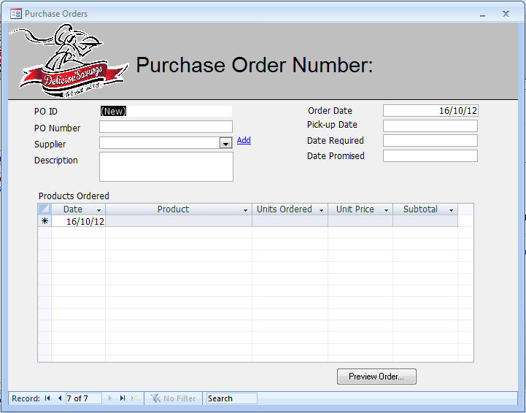Figure 33 - Purchase Order Form

The form above is called the Purchase Orders form and is used to enter the purchase order information. Some of the fields and buttons in this form, such as the PO ID, PO Number, the Order Date, the navigation buttons and the Search option have been discussed. The rest of the fields and buttons of this form will now be discussed.

3.7.1 The Supplier Field

The Supplier field, next to the Supplier label, provides the user with a list of all the suppliers of the company. If the supplier, the user is looking for, is not on the drop down list, the user can add the supplier by clicking on the Add button next to the Supplier field. After the button has been clicked, the form in Figure: 16, will appear on the screen.
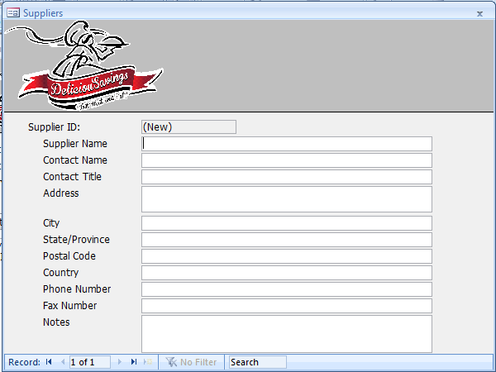Figure 34 - Suppliers Form

The Supplier ID field will automatically be generated by the system, but the rest of the supplier information can simply be entered by the user. As soon as all the supplier information has been entered and the record finished, the user can close the form and the supplier will be added to the system. The user will return to the Purchase Orders form.

3.7.2 The Description Field

The Description field below the Description label can be used by the user to enter any information regarding the purchase order that will not be captured by any other field. This is usually the description the supplier made on the companies invoice, if any.

3.7.3 The Pick-up Date and Date Required and –Promised Field

The Pick-up Date field is the date that the DeliciouSavings is planning to pick up or receive their order from the suppliers and should be entered by the user. The Date Required field is the field used to enter the date that the order needs to be received by DeliciouSavings. This can be because a customer delivery needs to be made that day or simply just because DeliciouSavings wants the stock at that day for whatever reason. The Date Promised field is the field available to enter on what date the purchase order will be ready, according to the suppliers. If there is no lead time on the purchase order, the user can enter the same date, as was entered, in the Order Date field.

3.7.4 The Products Ordered Label

Below the Products Ordered label, are all the fields that need to be filled out by the user in order to finish the purchase order record. These fields include the following:
- The Date field below the Date column. Here the user needs to enter the date the order is placed for the specific product.
- The Product field in the Product column. The user can simply click on the first available row and a drop down list button will appear. If the user clicks on the drop down list button, he/she will be able to select the product from the list.
- Units Ordered field in the Units Ordered column is where the user specifies the number of meals ordered
- The Unit Price field under the Unit Price column is where the unit price given by the supplier should be entered.
- The Subtotal field in the Subtotal column will automatically be calculated by the system when the information regarding the Units Ordered and Unit Price fields have been entered.
After all the information required on the Purchase Orders form has been entered, the user can simply close the form and return to the Products form. The new Purchase Orders information will now be visible, where applicable, on the Product form if the Inventory Transaction tab is selected.

3.8 Browse Purchase Orders Button

If the user is interested in browsing through the entire collection of different Purchase Orders that have been made, he/she can simply click on the Browse Purchase Orders Button below the Tasks label. A form similar to the form in Figure: 17 will appear.
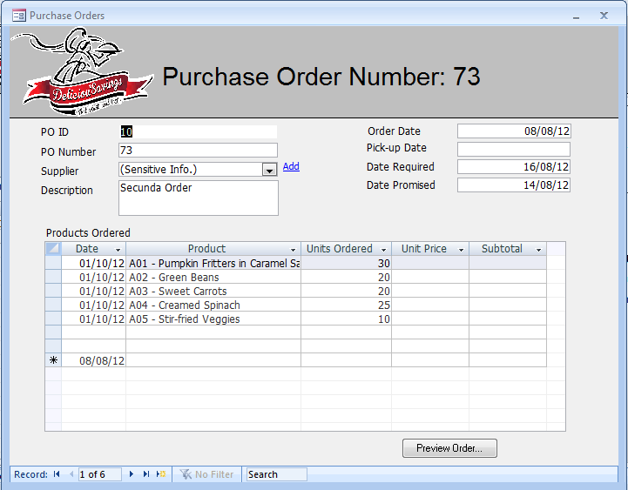Figure 35 - Browsing Purchase Orders

The user can use the navigation buttons at the bottom of the form to navigate between different purchase orders and simply exit the form to return to the Products form.

3.9 Add or Delete Employees Button

If the Add or Delete Employees button is selected below the Setup label, the same form, as the one discussed in Section: 2.2 and shown in Figure: 6 will appear, enabling the user to view, delete or add an employee.

3.10 Add or Delete Suppliers Button

See Section: 4.7.1 and Figure: 16.

3.11 Add or Delete Product Categories Button

See Section: 4.2 and Figure: 13.

3.12 Add or Delete Shipping Methods:

See Section: 2.3 and Figure: 7.

3.13 Change Our Company Information Button

The Change Our Company Information button on the Products form below the Setup label can be clicked by the user and the form shown in Figure: 18 will appear.
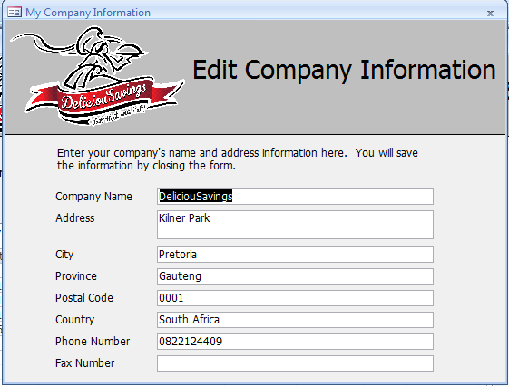
Figure 36 - My Company Information Form

Within the form, are all the fields with the current company information. It can be edited, viewed or changed and the information will automatically change throughout the rest of the system. When the user is finished, the document can simply be closed and the user will return to the Products form.

4. View Reports Button
The View Reports button in the Product form under the Tasks label is the last button to be discussed on the Products form and will be discussed throughout Section: 5. If the View Reports button is selected, the form displayed in Figure: 19, will appear on screen.
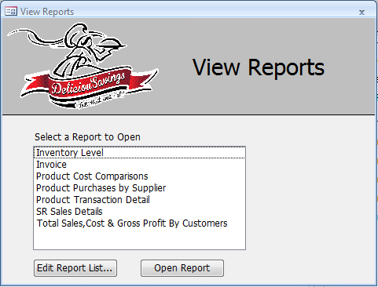
Figure 37 - View Reports Form

The View Reports form enables the user to navigate between the different reports.

4.1 Open Report Button.

At the bottom of the form there are two buttons available. The Open Report button can be used to open one of the reports available, in the field below the Select a Report to Open label. The user can use the up and down arrows on his/her keyboard to navigate between the different reports available in the field and click on the Open Report button once. If it is more convenient for the user, he/she can also double click on one of the reports in the list for the report to open up.

4.2 The Edit Report List Button

The Edit Report button is a button that will barely be used, unless the company would like to design a new report that will be added to the system. This report name can then be added to the list. If this happens, the user can click on the Edit Report List button and the form shown in Figure: 20 will open. The user can simply add the name of the new report in the next available row and close the form.
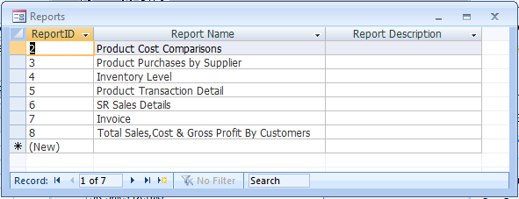Figure 38 - Reports Form

4.3 Inventory Level Report

If the user opens the Inventory Level Report available in the View Reports list, the report in Figure: 21 will appear on screen.
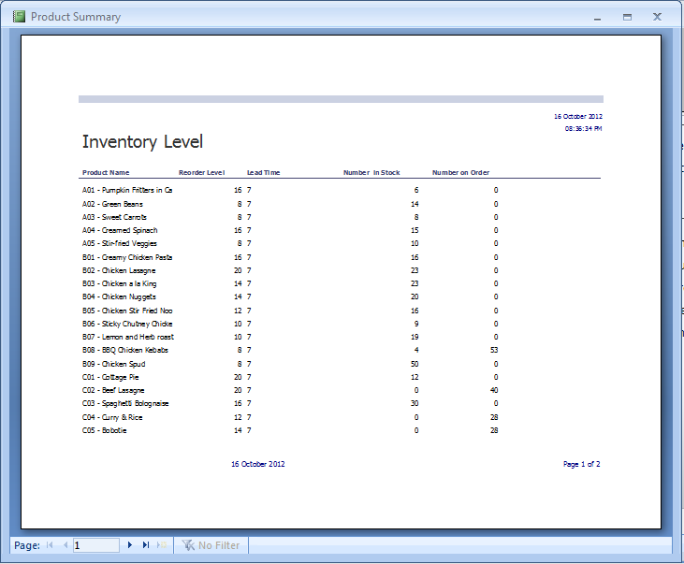Figure 39 - Inventory Level Report

All the products, with their associated re-order levels and lead times are available in this report, as well as the number of meals in stock and the number of meals on order. With the use of this form, it is much easier to manage inventory.

4.4 Invoice Report

The Invoice Report displays a lot of the information also displayed in the New Orders form and is automatically generated when new orders are made. It is very simple to use and can easily be saved, printed and e-mailed to the customer. The user can navigate between the different customer invoices using the navigation buttons. The Invoice Report can be seen in Figure: 22 below.
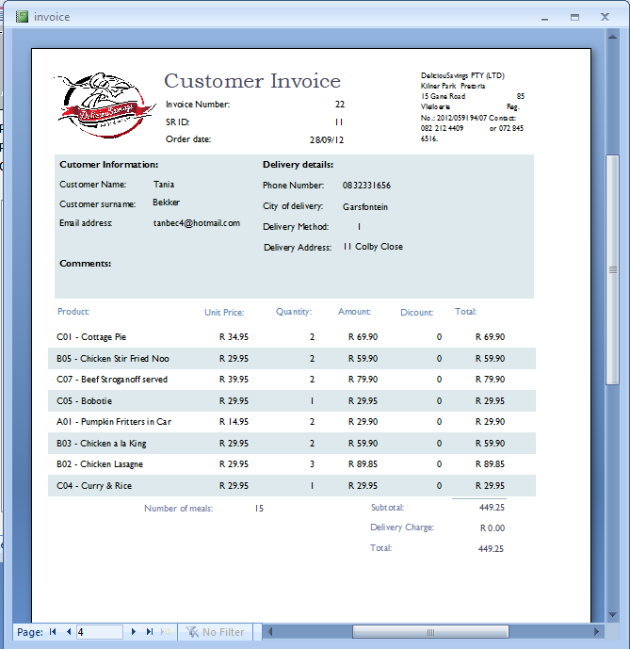Figure 40 - Invoice Report

4.5 Product Cost Comparison Report

The Product Cost Comparison report is a report available to the user, to make cost comparisons between different suppliers. The average price of each meal paid to suppliers, in the long run, can be measured in order to determine the supplier with the lowest costs. The total number of meals supplied by each Supplier for each meal can also be established.
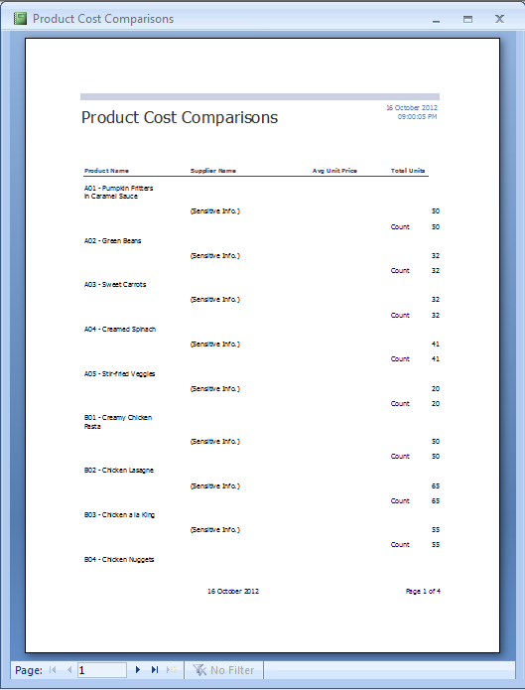
Figure 41 - Product Cost Comparisons Report

4.6.1 Product Purchases by Supplier Form

When trying to open up the Product Purchases by Supplier report, the form in Figure: 24 appears, asking the user to type in the beginning and ending dates.
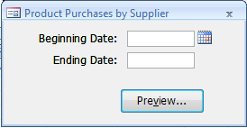
Figure 42 - Product Purchases by Supplier Form

The user needs to enter the dates and can use the calendar provided to do so. The dates are important since the dates will determine the information provided. The type of information provided will be the information applicable between the two dates entered by the user. After the dates have been entered, the user can click on the Preview button on the form, to view the Product Purchases by Supplier report.

4.6.2 Product Purchases by Supplier Report

The Product Purchases by Supplier report can be viewed by the user to determine the number of each of the meals, bought from each supplier within the specified dates provided by the user in the Product Purchases by Supplier form.
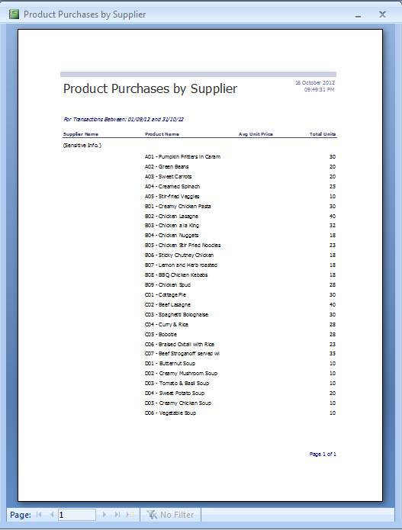
Figure 43 - Product Purchases by Supplier Report

4.7 Product Transaction Detail Report

The Product Transaction Detail Report provides the user with all the information regarding each product’s transactions. It will show a summary of the number of meals ordered, received, sold and the number of meals lost to shrinkage.
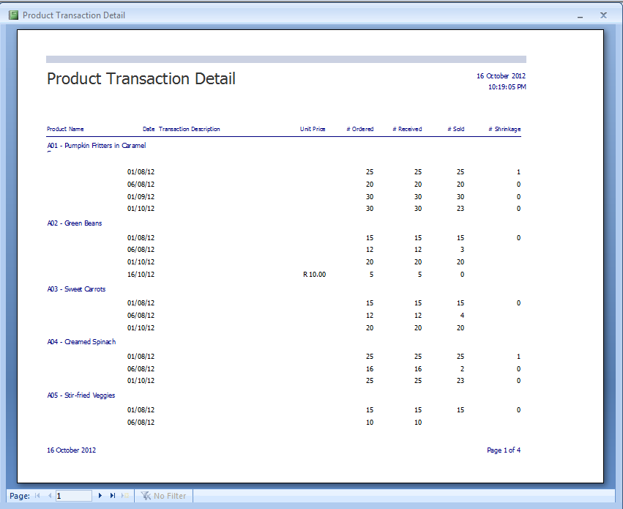Figure 44 - Product Transaction Detail Report

4.8 SR Sales Details Report

Before being able to open the SR Sales Details report, the system will inquire the user to fill in a start and end date. Refer to Section: 5.6.1 and Figure: 24 for instructions. After the dates have been entered by the user, the report results will be displayed. The SR Sales Details report is used to show the number of meals sold by each SR at the end of each month, as well as the total amount of sales that each SR made. These values can be used to determine the amount of commission that needs to be paid to each SR at the end of each month.
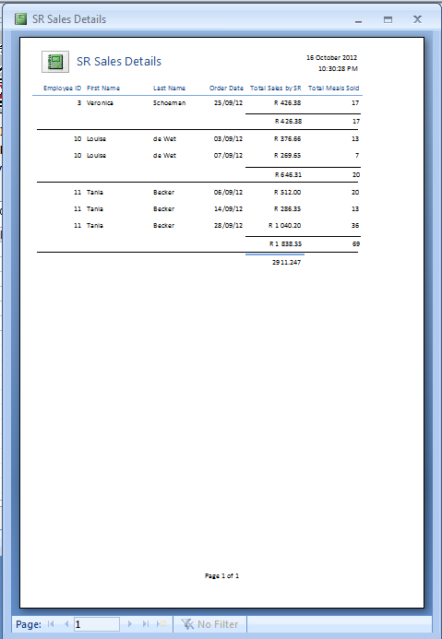Figure 45 - SR Sales Details Report

4.9 Gross Profit by Customers Report
The Gross Profit by Customers report shows all the information regarding the sales totals, the cost of sales and the gross profit per order, as well as the totals per customer.
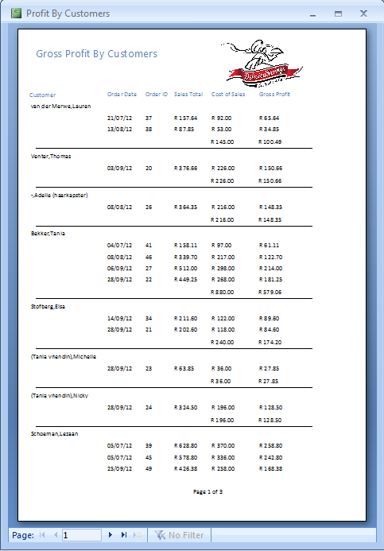
Figure 46 - Gross Profit by Customers Report

